Motor-CAD Project Report

D106 H65 25sp DT ( 2x0.63 + 2x0.5 ).mot

E-Magnetic

Geometry

Radial

Image: Radial Cross Section
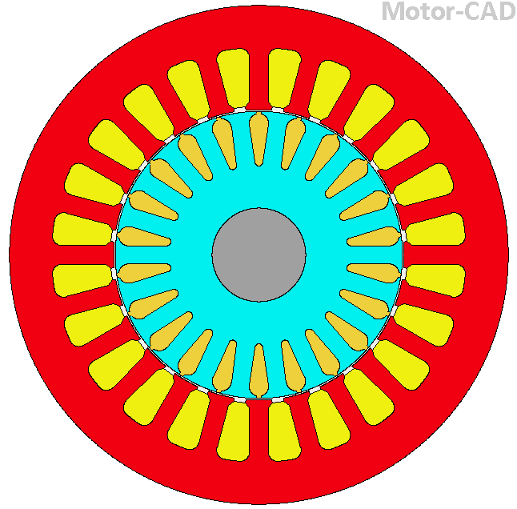

Table: Radial Cross Section 1
Stator Parameters | Value
Slot Number | 24
Stator Lam Dia | 106.5
Stator Bore | 62
Tooth Width | 3.996
Slot Depth | 13.25
Slot Corner Radius | 2
Tooth Tip Depth | 0.67
Slot Opening | 2.5
Tooth Tip Angle | 45
Sleeve Thickness | 0

Table: Radial Cross Section 2
Rotor Parameters | Value
Rotor Bars | 22
Pole Number | 4
Bar Opening [T] | 1
Bar Opening Depth [T] | 0.48
Bar Opening Radius[T] | 2.06
Bar Depth [T] | 11.17
Bar Corner Radius [T] | 0.88
Airgap | 0.35
Banding Thickness | 0
Shaft Dia | 20
Shaft Hole Diameter | 0

Screenshot
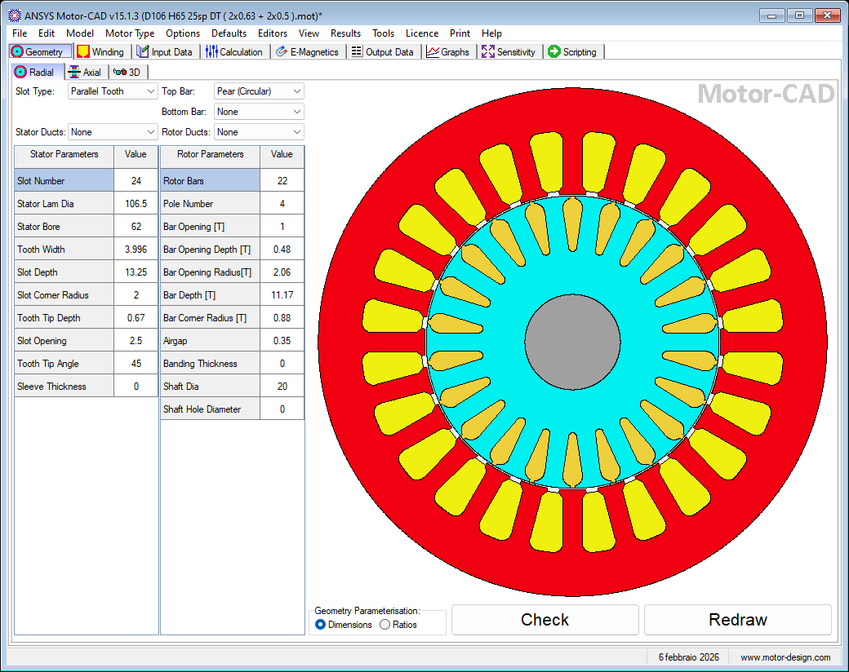

Axial

Image: Axial Cross Section
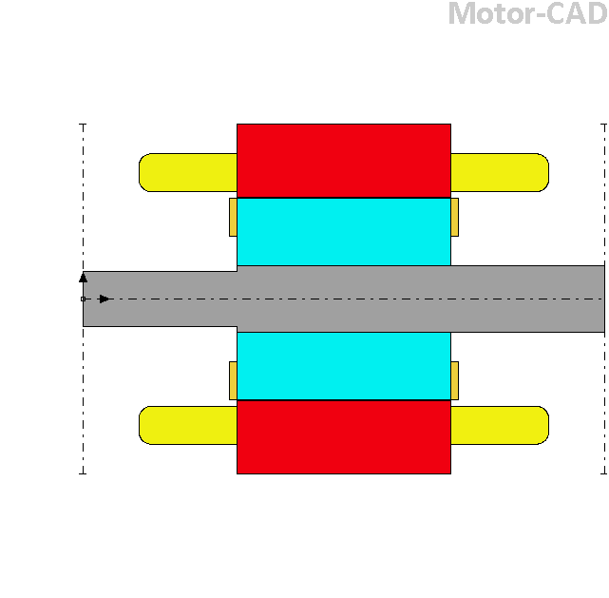

Table: Axial Cross Section 1
Radial Dimensions | Value
Stator Lam Dia | 106.5
Stator Bore | 62
Airgap | 0.35
Banding Thickness | 0
Sleeve Thickness | 0
EndRing Add [Outer F] | 0
EndRing Add [Outer R] | 0
EndRing Add [Inner F] | 0
EndRing Add [Inner R] | 0
Shaft Dia | 20
Shaft Dia [F] | 17
Shaft Dia [R] | 20
Shaft Hole Diameter | 0

Table: Axial Cross Section 2
Axial Dimensions | Value
Motor Length | 159
Stator Lam Length | 65
Rotor Lam Length | 65
EWdg Overhang [F] | 30
EWdg Overhang [R] | 30
Wdg Extension [F] | 5
Wdg Extension [R] | 5
EndRing Thickness [F] | 2.5
EndRing Thickness [R] | 2.5
EndRing Extension [F] | 0
EndRing Extension [R] | 0
Shaft Extension [F] | 0
Shaft Extension [R] | 0

Screenshot
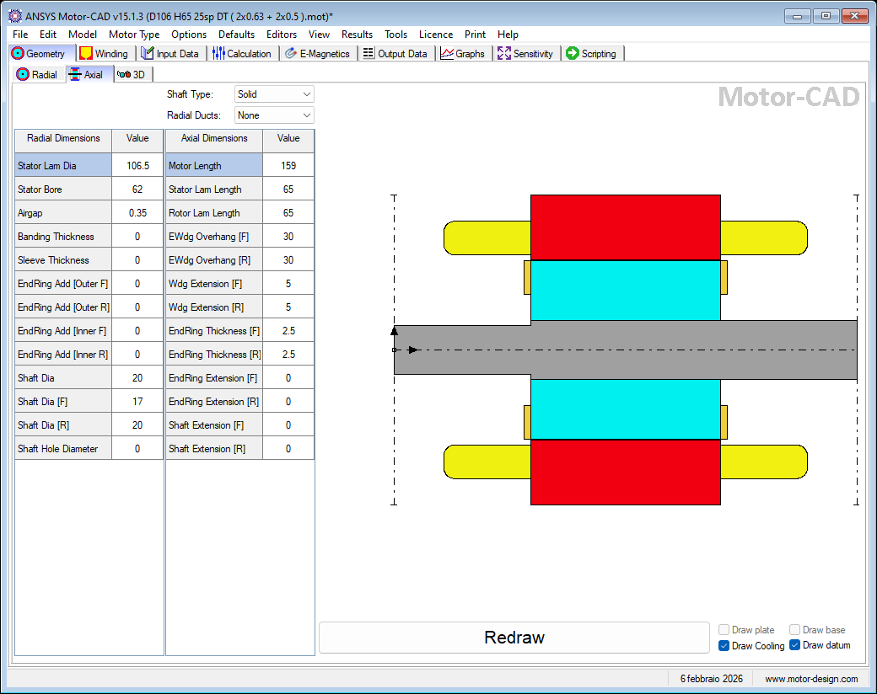

3D

Image: 3D
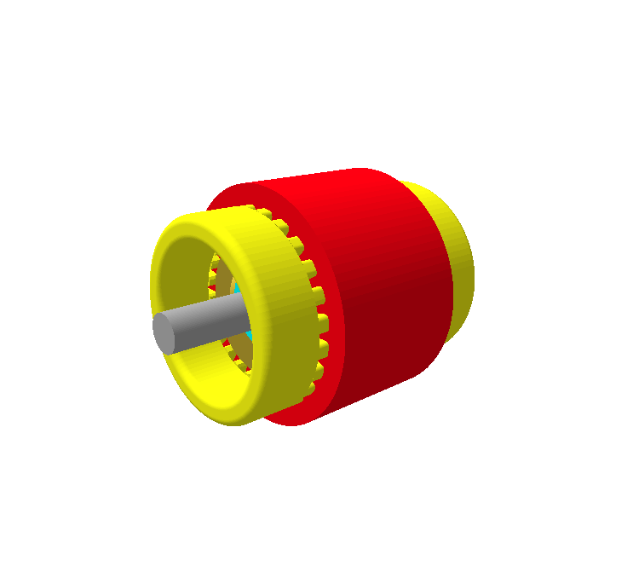

Screenshot
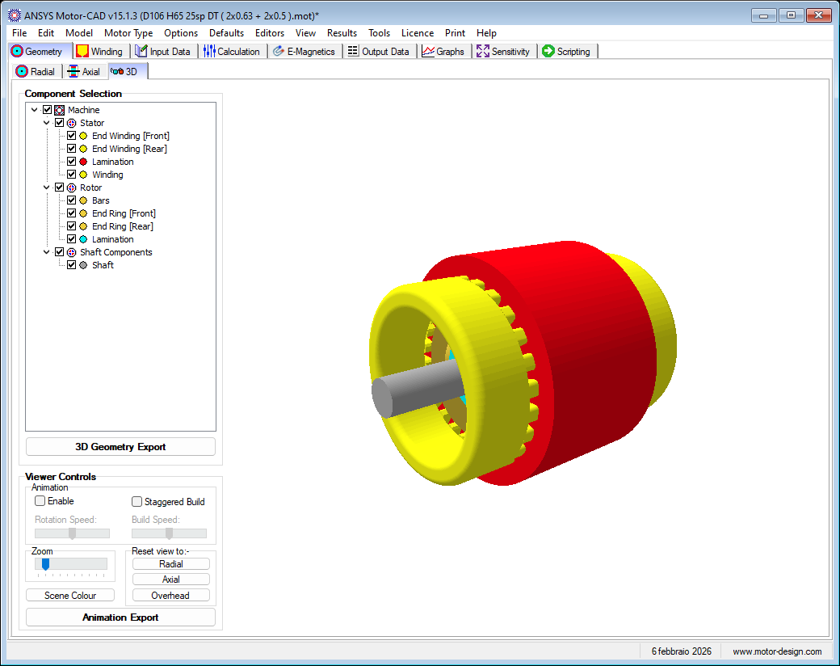

Winding

Pattern

Radial Pattern

Image: Winding Pattern
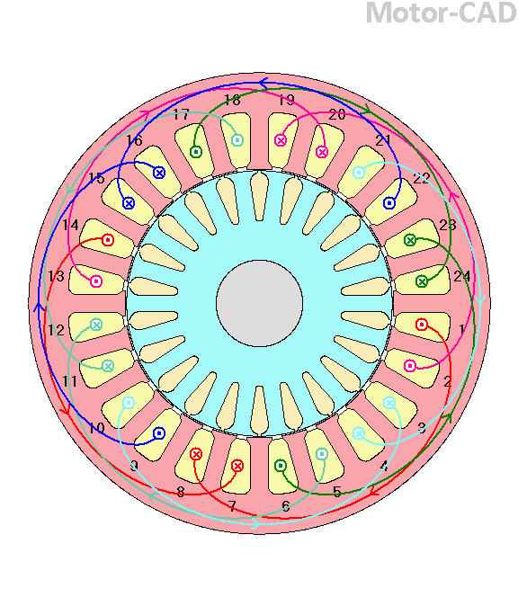

Screenshot
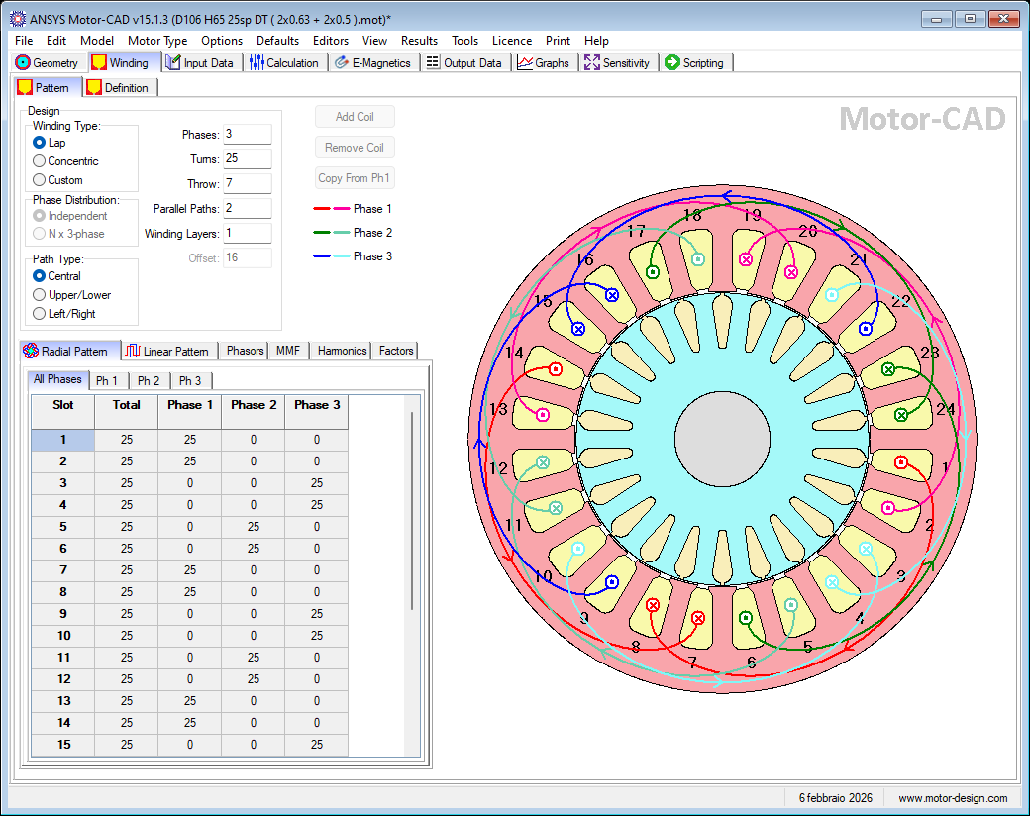

Linear Pattern

Image: Winding Pattern
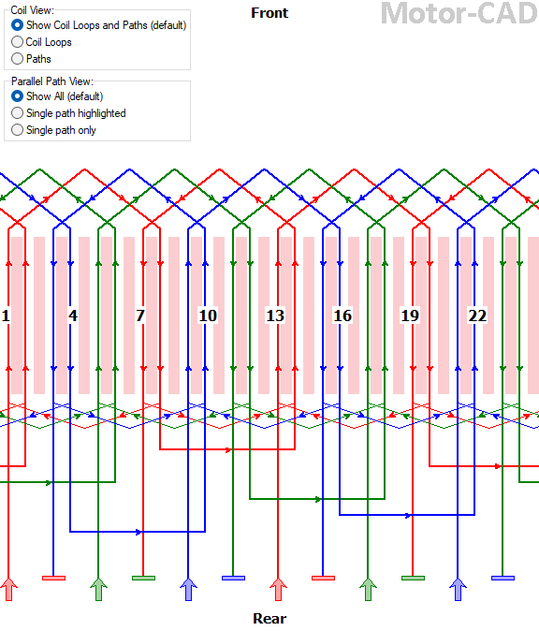

Screenshot
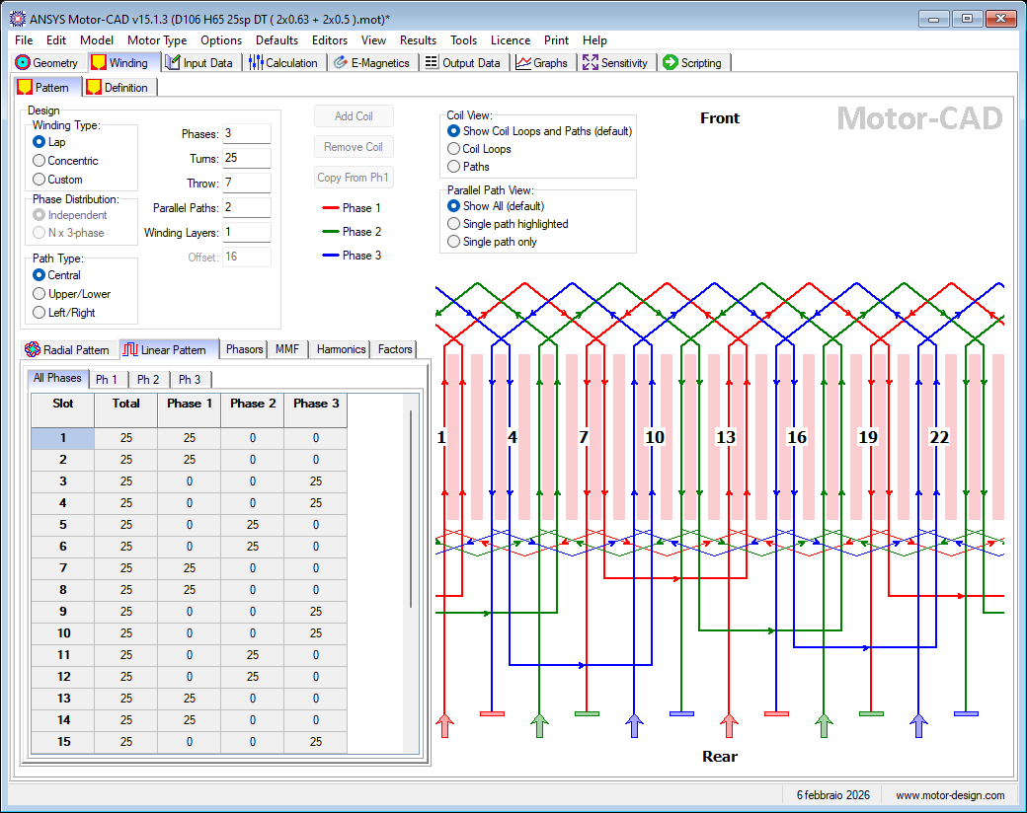

Phasors

Table: Phasors All
 | Ph 1 | Ph 2 | Ph 3
Angle [EDeg] | 0 | 120 | 240
MMF [Amp Turns] | 193.185 | 193.185 | 193.185

Image: Winding Pattern
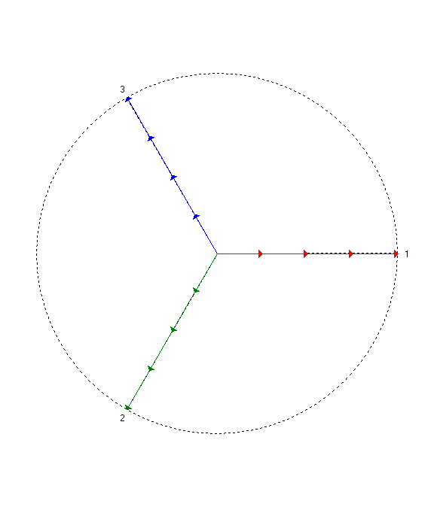

Screenshot
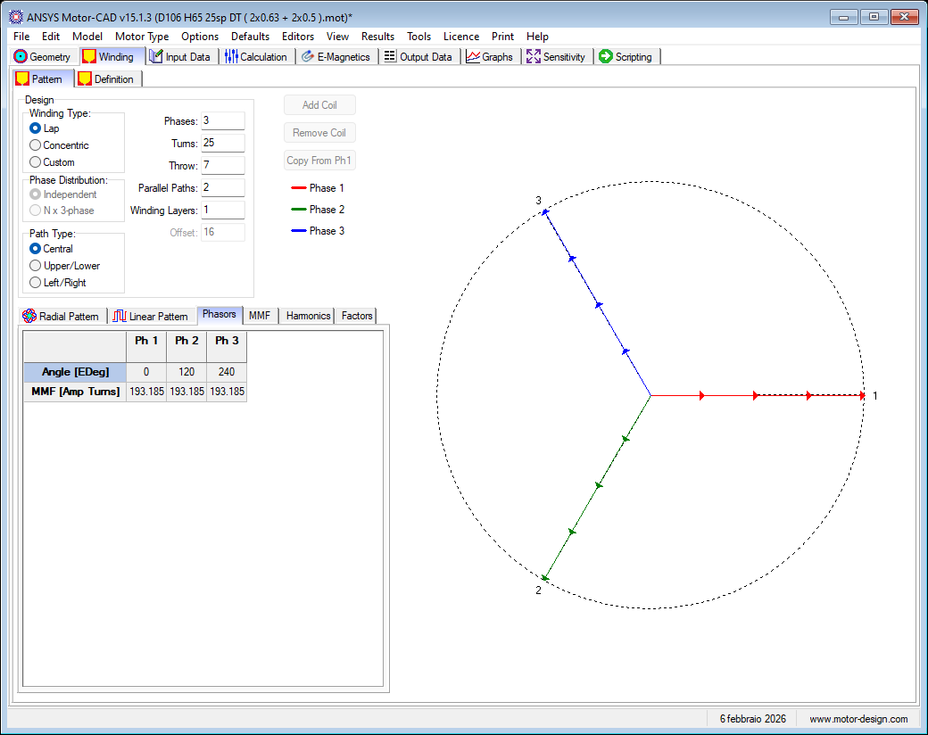

MMF

Table: Winding MMF
Slot | MMF [Amp Turns]
0 | -25.0
1 | 0.0
2 | 25.0
3 | 25.0
4 | 25.0
5 | 25.0
6 | 25.0
7 | 0.0
8 | -25.0
9 | -25.0
10 | -25.0
11 | -25.0
12 | -25.0
13 | 0.0
14 | 25.0
15 | 25.0
16 | 25.0
17 | 25.0
18 | 25.0
19 | 0.0
20 | -25.0
21 | -25.0
22 | -25.0
23 | -25.0
24 | -25.0

Graph: Winding MMF
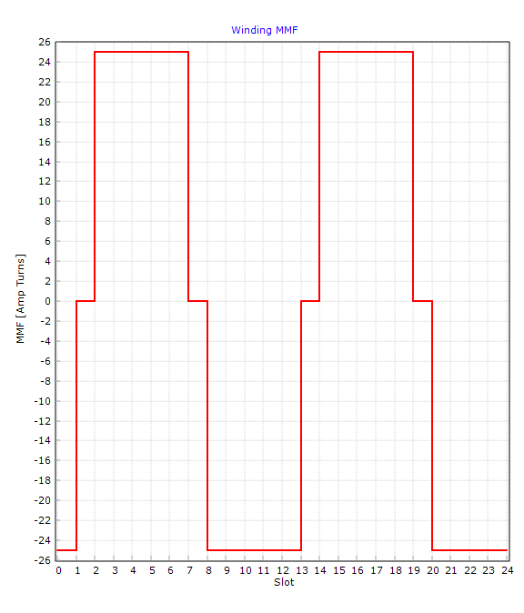

Screenshot
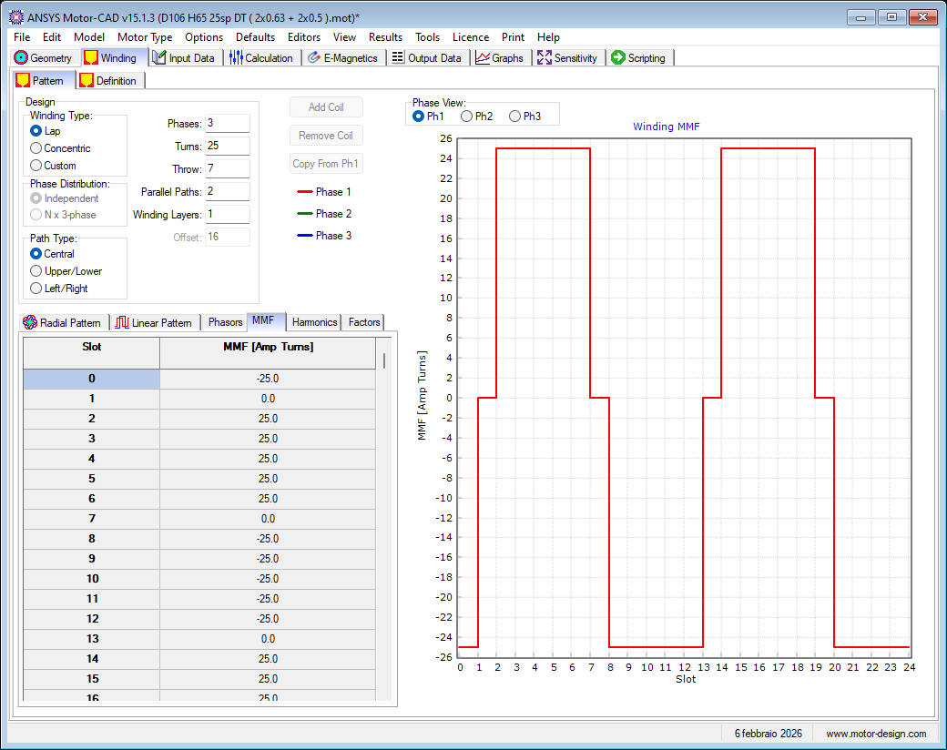

Harmonics

Table: Winding Harmonics
Mechanical Harmonic | MMF [Amp Turns]
1 | 0.000000
2 | 30.297413
3 | 0.000000
4 | 0.000000
5 | 0.000000
6 | 6.553800
7 | 0.000000
8 | 0.000000
9 | 0.000000
10 | 1.111603
11 | 0.000000
12 | 0.000000
13 | 0.000000
14 | 0.507723
15 | 0.000000
16 | 0.000000
17 | 0.000000
18 | 0.481571
19 | 0.000000
20 | 0.000000
21 | 0.000000
22 | 0.000543
23 | 0.000000
24 | 0.000000
25 | 0.000000
26 | 0.284383
27 | 0.000000
28 | 0.000000
29 | 0.000000
30 | 0.246345
31 | 0.000000
32 | 0.000000
33 | 0.000000
34 | 0.070657
35 | 0.000000
36 | 0.000000
37 | 0.000000
38 | 0.039433
39 | 0.000000
40 | 0.000000
41 | 0.000000
42 | 0.029646
43 | 0.000000
44 | 0.000000
45 | 0.000000
46 | 0.029531
47 | 0.000000
48 | 0.000000
49 | 0.000000
50 | 0.058203
51 | 0.000000
52 | 0.000000
53 | 0.000000
54 | 0.040374
55 | 0.000000
56 | 0.000000
57 | 0.000000
58 | 0.009607
59 | 0.000000
60 | 0.000000
61 | 0.000000
62 | 0.003898
63 | 0.000000
64 | 0.000000
65 | 0.000000
66 | 0.000026
67 | 0.000000
68 | 0.000000
69 | 0.000000
70 | 0.005262
71 | 0.000000
72 | 0.000000
73 | 0.000000
74 | 0.003762
75 | 0.000000
76 | 0.000000
77 | 0.000000
78 | 0.000058
79 | 0.000000
80 | 0.000000
81 | 0.000000
82 | 0.000645
83 | 0.000000
84 | 0.000000
85 | 0.000000
86 | 0.000410
87 | 0.000000
88 | 0.000000
89 | 0.000000
90 | 0.001402
91 | 0.000000
92 | 0.000000
93 | 0.000000
94 | 0.005857
95 | 0.000000
96 | 0.000000
97 | 0.000000
98 | 0.008133
99 | 0.000000
100 | 0.000000

Graph: Winding Harmonics (mechanical)
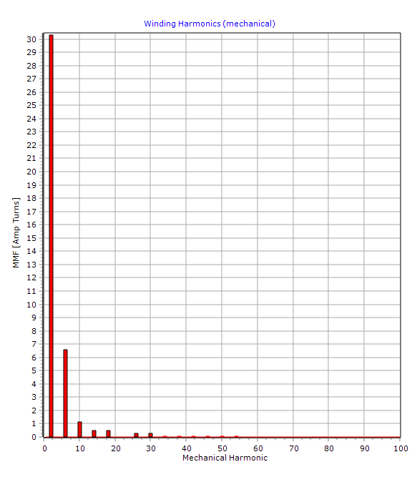

Screenshot
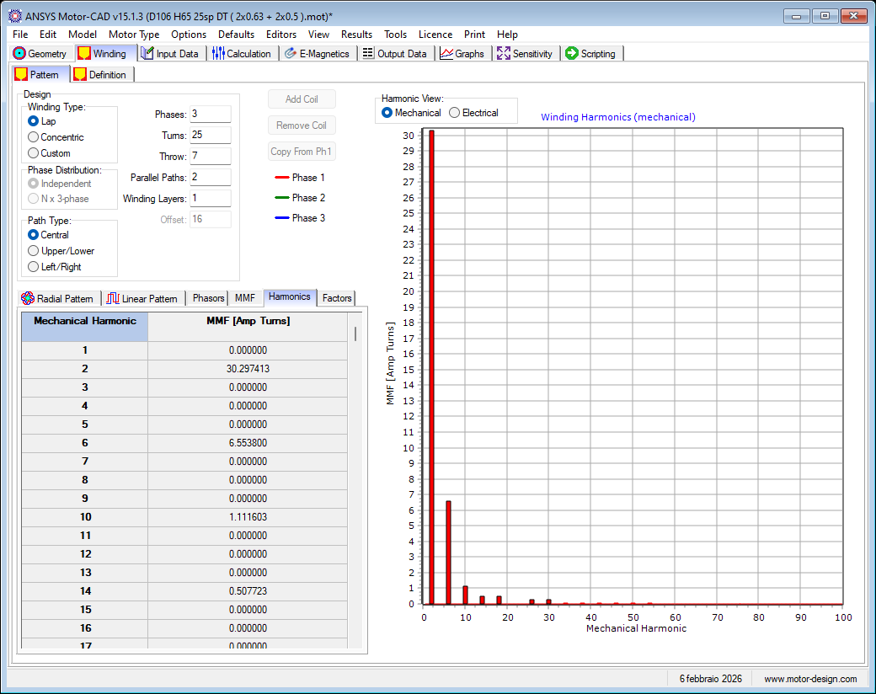

Factors

Table: Winding Factors
Harmonic | Magnitude
1 | 0.952854
3 | 0.623748
5 | 0.179433
7 | 0.117812
9 | 0.148894
11 | 0.000215
13 | 0.140505
15 | 0.150110
17 | 0.052785
19 | 0.036092
21 | 0.033374
23 | 0.041231
25 | 0.102123
27 | 0.090763
29 | 0.028456
31 | 0.015857
33 | 0.000157
35 | 0.052074
37 | 0.083077
39 | 0.062874
41 | 0.016746
43 | 0.005994
45 | 0.015353
47 | 0.054255
49 | 0.068304

Graph: Winding Factors
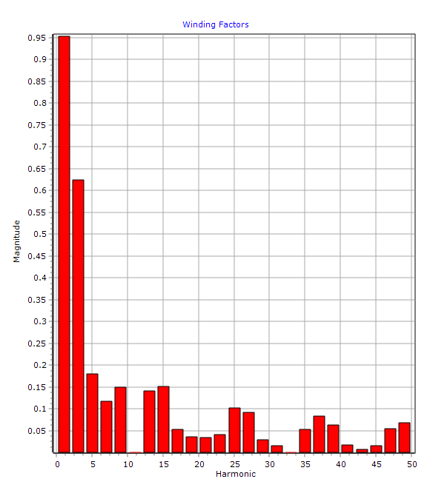

Screenshot
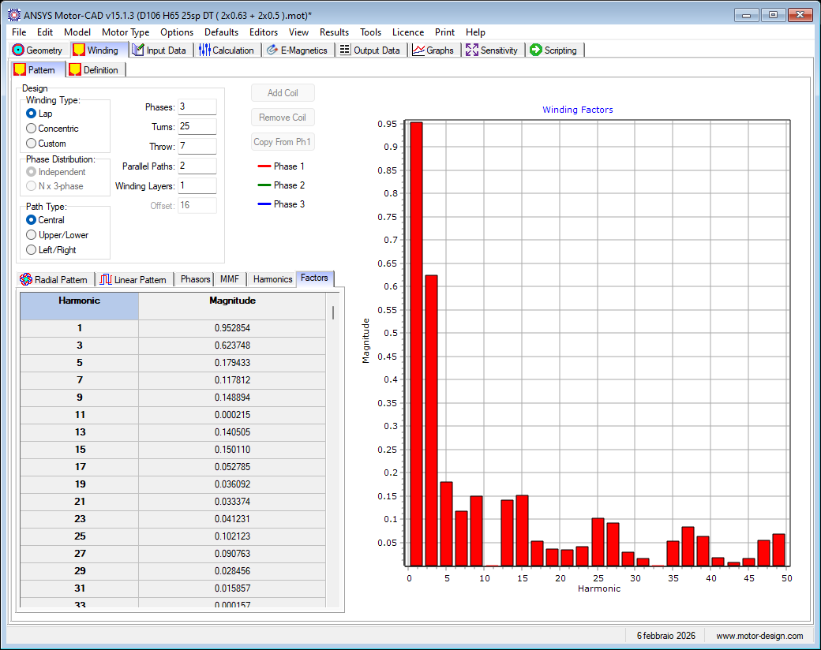

Definition

Table: Winding Editor 2
Input Parameter | Value
Number Of Wire Sizes | 1
Conductors/Slot | 100
EWdg MLT | 237.899

Table: Winding Editor 1
Input Parameter | Value
Wire Slot Fill | 0.5046
EWdg Fill | 0.5938
Liner Thickness | 0.25
Conductor Separation | 0.1

Image: Winding Editor
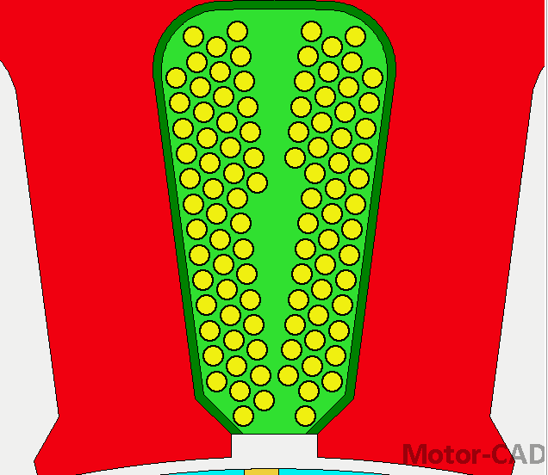

Table: Winding Output 1
Output Parameter | Value
Conductors/Slot Drawn | 100
Wire Slot Fill (Wdg Area) | 0.5046
Wire Slot Fill (Slot Area) | 0.4498
Copper Slot Fill (Slot Area) | 0.3544
Heavy Build Slot Fill | 0.6425

Table: Winding Output 2
Output Parameter | Value
Slot Area | 71.74
Winding Area (+ Liner) | 71.74
Winding Area | 63.95
Winding Depth | 12.3552

Table: Winding Output 3
Output Parameter | Value
Covered Wire Area | 32.27
Copper Area | 25.43
Impreg Area | 31.68
Wedge Area | 0

Screenshot
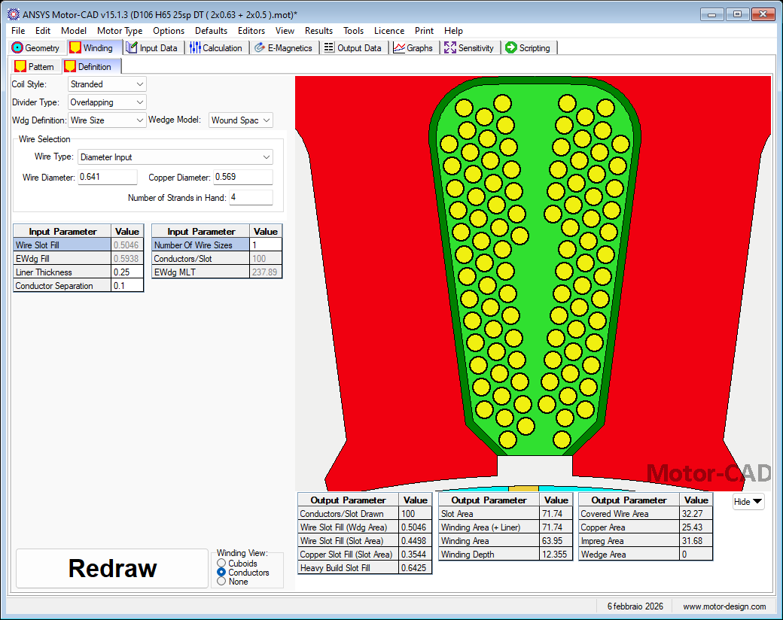

Input Data

Materials

Table: Materials Weights
Component | Material from Database | Electrical Resistivity | Temp Coef Electrical Resistivity | Density | Weight | Notes
Units |  | Ohm.m |  | kg/m³ | kg
Stator Lam (Back Iron) | M800-50A | 2.3E-07 | 0 | 7650 | 1.302
Stator Lam (Tooth) | M800-50A | 2.3E-07 | 0 | 7650 | 0.6478
Stator Lamination [Total] |  |  |  |  | 1.95
Armature Winding [Active] | Copper (Annealed) | 1.724E-08 | 0.00393 | 8933 | 0.3544
Armature EWdg [Front] | Copper (Annealed) | 1.724E-08 | 0.00393 | 8933 | 0.3242
Armature EWdg [Rear] | Copper (Annealed) | 1.724E-08 | 0.00393 | 8933 | 0.3242
Armature Winding [Total] |  |  |  |  | 1.003
Rotor Lam (Back Iron) | M800-50A | 2.3E-07 | 0 | 7650 | 0.3873
Rotor Lam (Tooth) | M800-50A | 2.3E-07 | 0 | 7650 | 0.5172
Rotor Lamination [Total] |  |  |  |  | 0.9046
Rotor Cage Top Bar | Aluminium (Cast) | 3.3E-08 | 0.00375 | 2950 | 0.1365
Rotor Cage Top Bar Opening | Aluminium (Cast) | 3.3E-08 | 0.00375 | 2950 | 0.002036
Rotor Cage (Front End) | Aluminium (Cast) | 3.3E-08 | 0.00375 | 2950 | 0.0134
Rotor Cage (Rear End) | Aluminium (Cast) | 3.3E-08 | 0.00375 | 2950 | 0.0134
Rotor Cage [Total] |  |  |  |  | 0.1653
Shaft [Active] | Mild Steel | 1.43E-07 | 0 | 7800 | 0.1593
Shaft [Front] | Mild Steel | 1.43E-07 | 0 | 7800 | 0.08321
Shaft [Rear] | Mild Steel | 1.43E-07 | 0 | 7800 | 0.1152
Shaft [Total] |  |  |  |  | 0.3577
Total |  |  |  |  | 4.38 | Weight [Total]

Screenshot
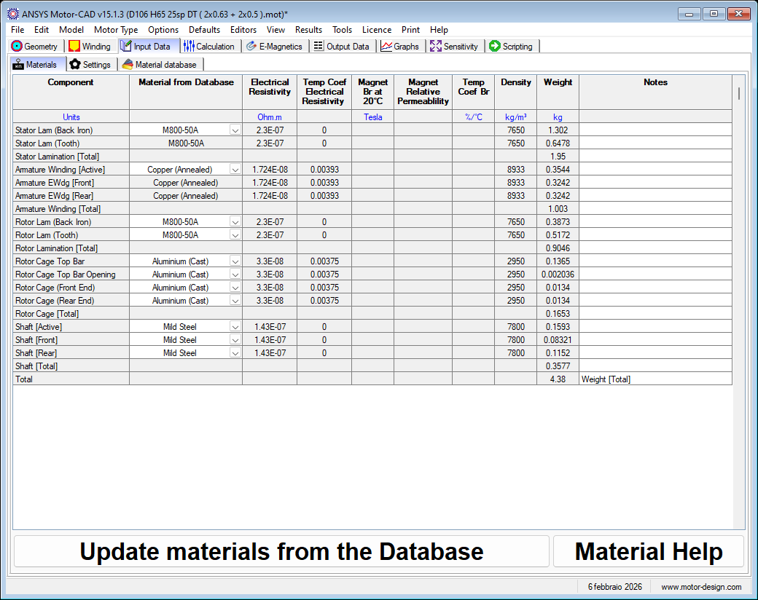

Settings

Geometry

Screenshot
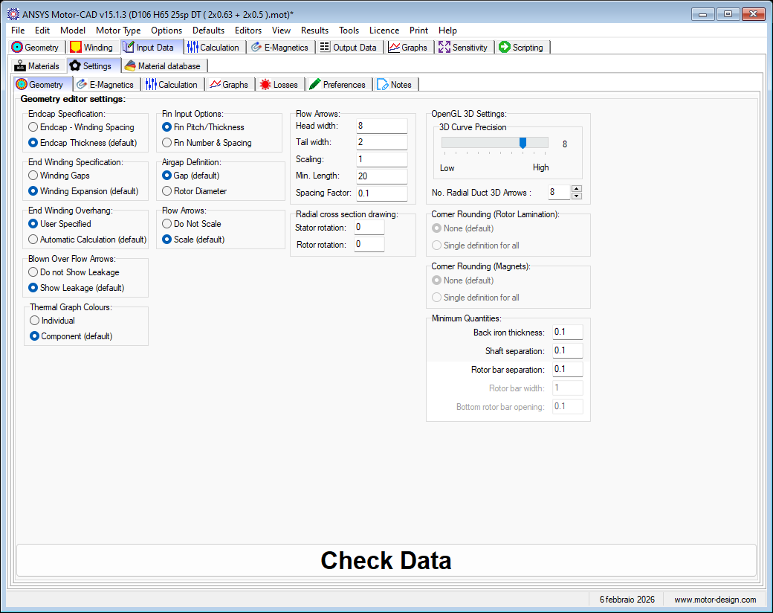

E-Magnetics

Screenshot
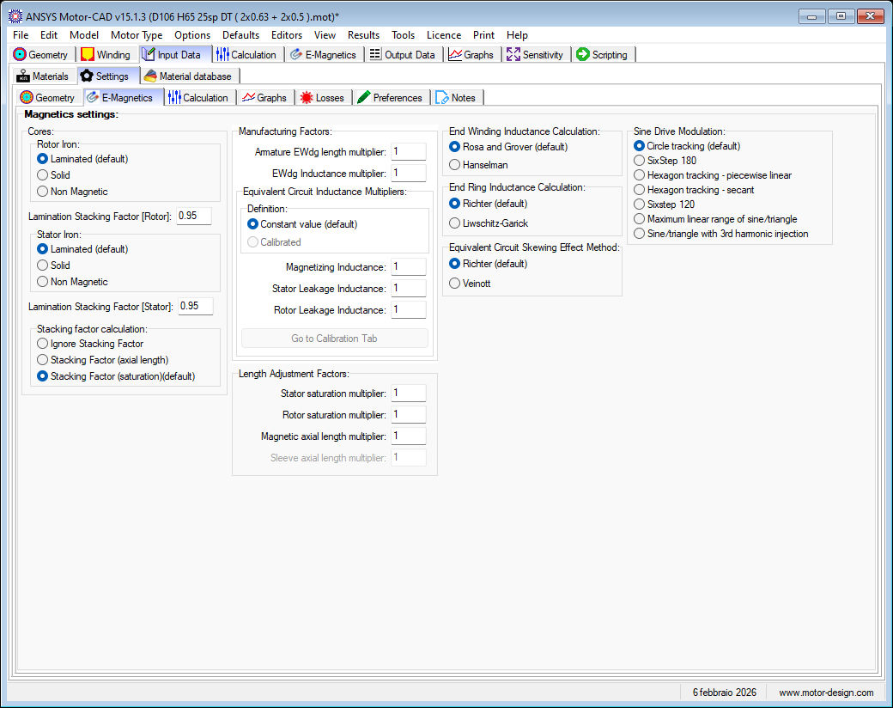

Calculation

Screenshot
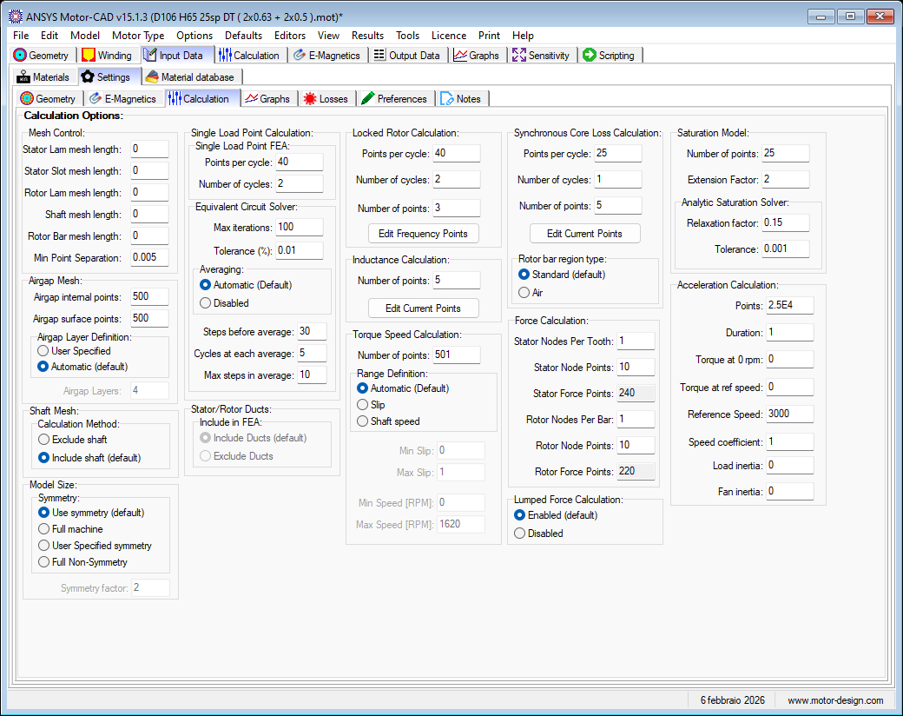

Graphs

Screenshot
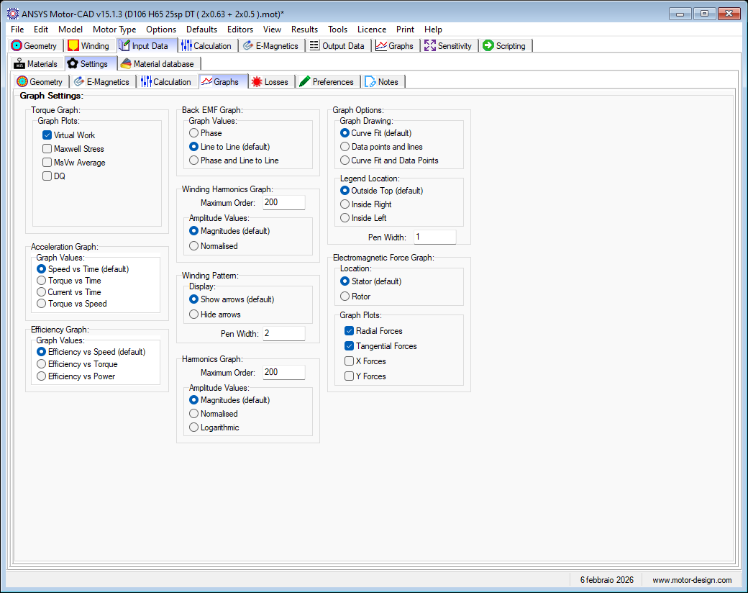

Losses

General

Screenshot
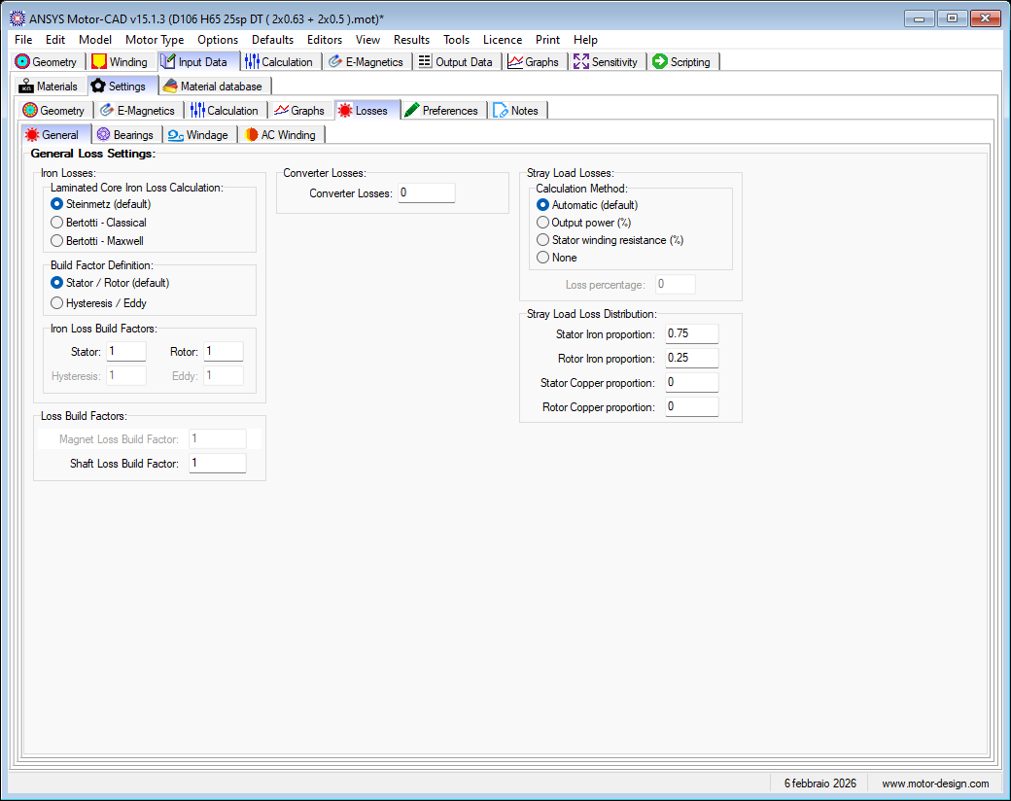

Bearings

Graph: Bearing Losses
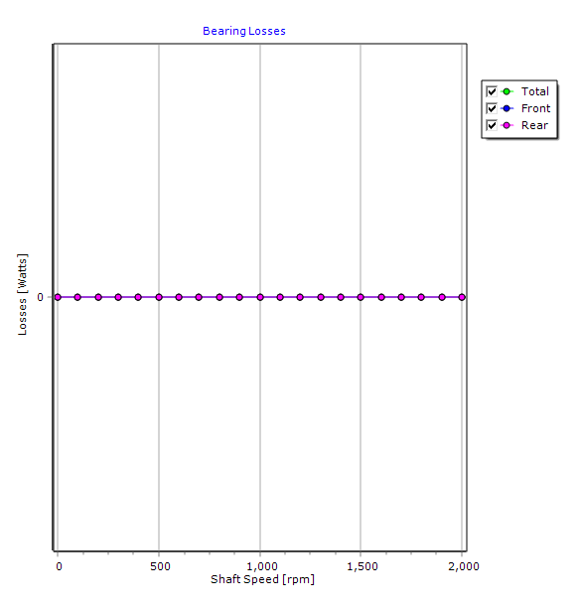

Screenshot
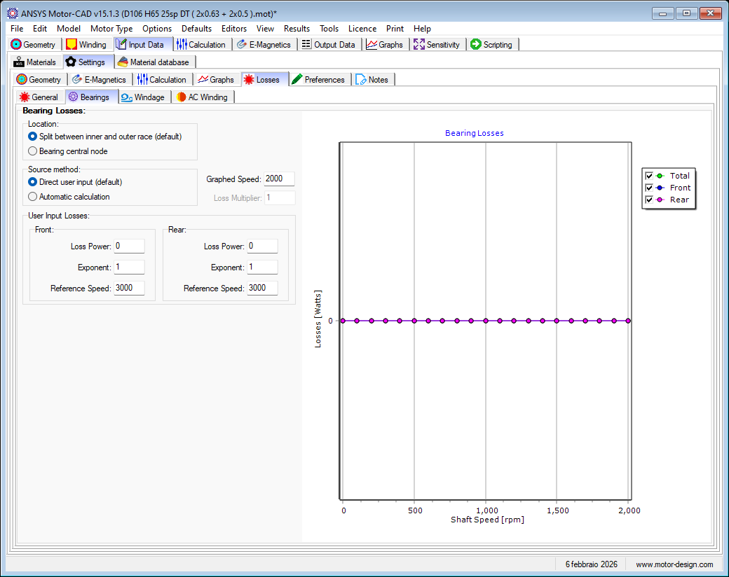

Windage

Graph: Windage Losses
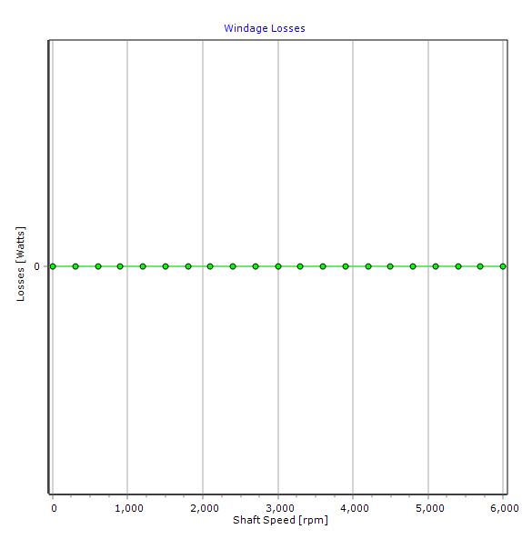

Screenshot
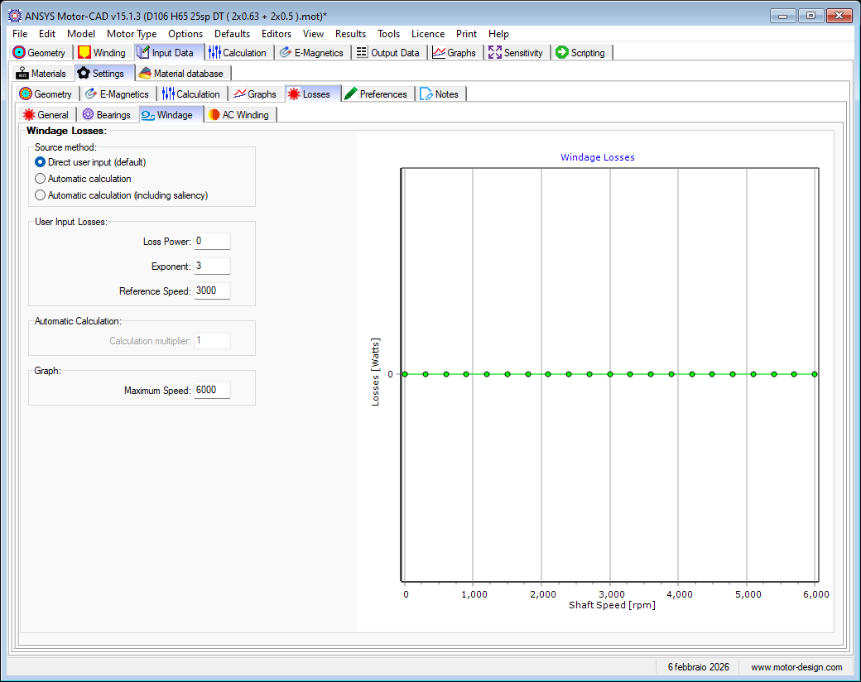

AC Winding

Table: Proximity
Cuboid No. | AC Loss Proportion
1 | 0
2 | 0

Screenshot
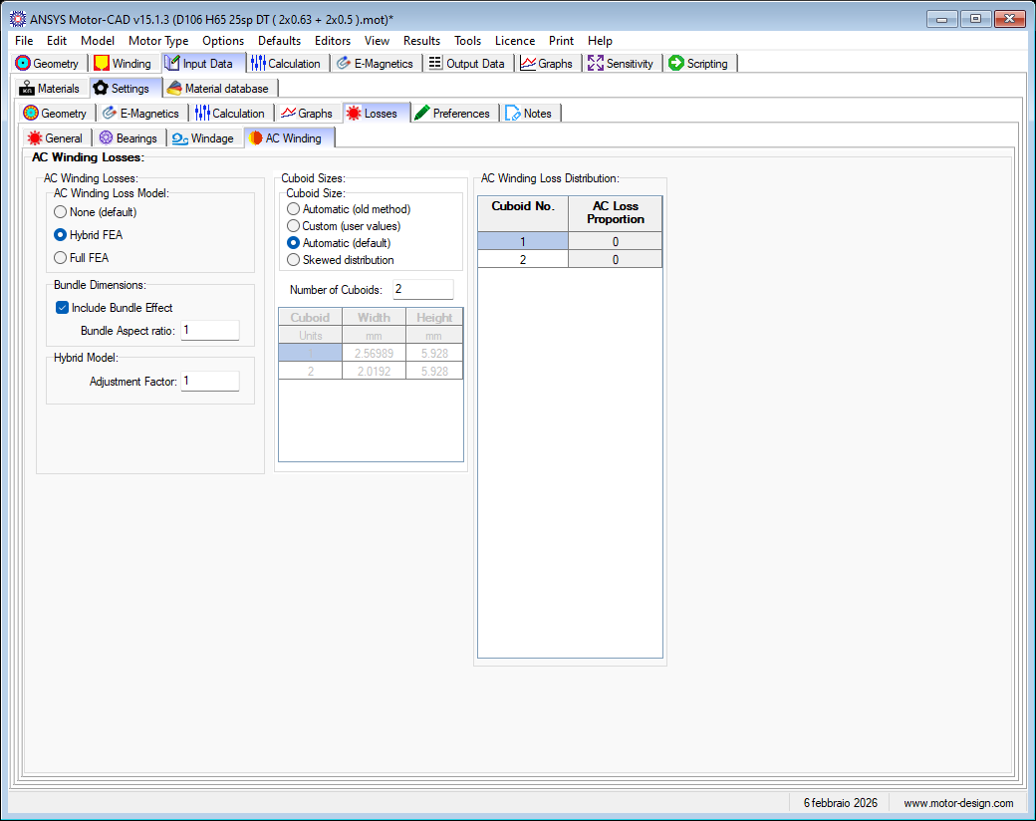

Preferences

Screenshot
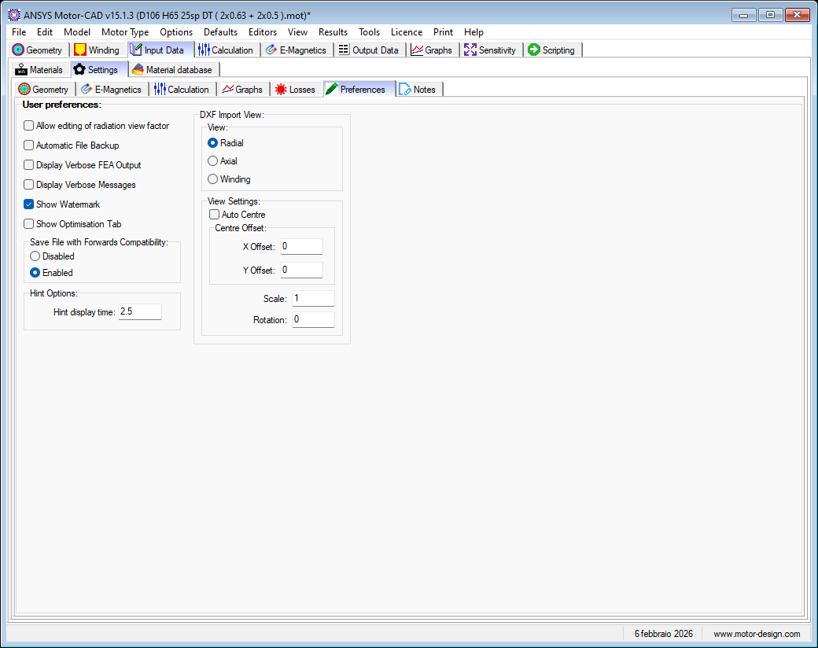

Notes

Screenshot
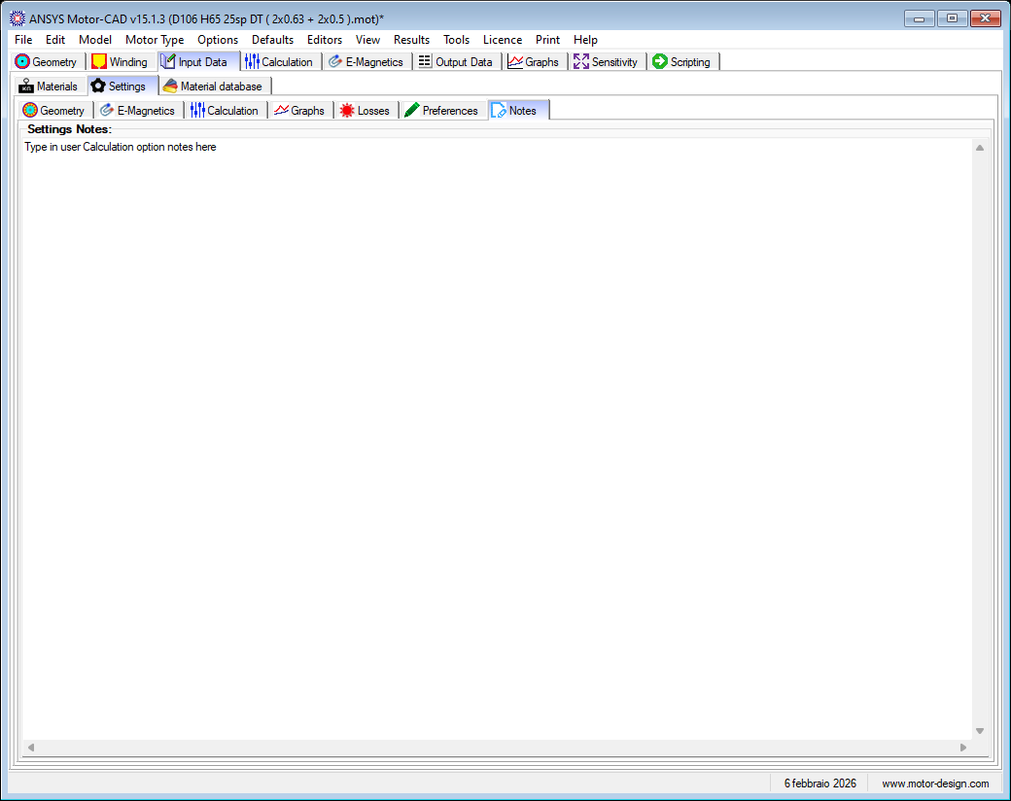

Material database

Solids

Physical

Table: Solid Material List
Material Name | Thermal Conductivity | Specific Heat | Density | Material Type | Notes
Units | W/m/°C | J/kg/°C | kg/m³
Aluminium (Alloy 195 Cast) | 168 | 833 | 2790 | General
Aluminium (Alloy 195 Cast)_Conduttività ridotta | 110 | 833 | 2790 | General | Autogenerated 01/12/2025 15:08:32. Solid database entry from mot file C:\Users\grell\Desktop\TRAINING MOTORCAD\D200 H160 5sp DT ( 10x0.95 + 2x0.9 )_v4_175A.mot. Solid database entry did not exist.
Aluminium (Cast) | 180 | 963 | 2950 | General
Arnon 7 3.25% Si | 30 | 450 | 7650 | Steel
Brass (70% Cu, 30% Zn) | 111 | 385 | 8522 | General
Carbon Fibre | 0.59 | 1000 | 1600 | General
Copper (Annealed) | 401 | 385 | 8933 | General | Autogenerated 12/12/2025 10:21:12 from C:\Users\grell\Desktop\MCAD_Corr\106 65 45 48 - Copia\D106 H65 45sp DT ( 1x0.71 + 1x0.5 ).mot
Copper (Annealed)_D135 H100 12sp DT ( 2x0 ).mot | 401 | 385 | 8933 | General | Autogenerated 02/07/2025 12:27:23 from C:\Users\grell\Desktop\MCAD_Corr\a\D135 H100 12sp DT ( 2x0.9 + 2x0.8 ).mot
Copper (Annealed)_D150 H120 6sp DT ( 8x0ot | 401 | 385 | 8933 | General | Autogenerated 11/12/2025 16:56:42 from C:\Users\grell\Desktop\MCAD_Corr\150 120 6 48 v2\PERDITE\D150 H120 6sp DT ( 8x0.9 ) 48V.mot
Copper (Annealed)_D150 H120 7sp DT ( 8x0 | 401 | 385 | 8933 | General | Autogenerated 11/12/2025 16:52:11 from C:\Users\grell\Desktop\MCAD_Corr\150 120 7 48 - PERDITE\D150 H120 7sp DT ( 8x0.85 ).mot
Copper (Pure) | 401 | 385 | 8933 | General
Electrographitic EG362 | 200 | 700 | 1600 | General
Epoxy | 0.22 | 1500 | 1200 | General
FB3X | 4 | 700 | 4800 | Magnet
Hiperco 50 (0.15mm) | 29.8 | 460 | 8110 | Steel
HS 50 | 47 | 420 | 8150 | General
Inconel 718 | 11.4 | 435 | 7800 | General
Iron (Cast) | 52 | 420 | 7272 | General
Iron (Pure) | 80 | 447 | 7870 | General
Iron (Silicon 1%) | 42 | 460 | 7769 | General
Iron (Silicon 2%) | 28 | 460 | 7600 | General
Iron (Silicon 5%) | 19 | 460 | 7417 | General
JFE_10JNEX900 | 30 | 450 | 7490 | Steel
Lamierino_Quadro_M530-50A | 30 | 460 | 7650 | General | Autogenerated 02/07/2025 11:19:21. Solid database entry from mot file C:\Users\grell\Desktop\GR100 H095 5sp DT ( 8x0.95 + 2x0.9 ).mot. Solid database entry did not exist.
LORD CoolTherm EP-2000 | 1.9 | 733 | 2720 | General
M1000-65A | 30 | 460 | 7650 | Steel
M19 24 Gauge Steel | 28 | 460 | 7800 | Steel
M19 26 Gauge Steel | 28 | 460 | 7800 | Steel
M19 29 Gauge Steel | 28 | 460 | 7800 | Steel
M235-35A | 30 | 460 | 7650 | Steel
M250-35A | 30 | 460 | 7650 | Steel
M270-35A-SPIN_copy | 22 | 460 | 7600 | Steel | Autogenerated 04/09/2025 15:10:26 from C:\Users\grell\Desktop\DINAMICOIL\D150 H48 38sp ST (1x1.4).mot
M270-50A | 22 | 460 | 7600 | Steel | Autogenerated 18/07/2025 15:13:47 from C:\Users\grell\Documents\MOTORE IPM\STUDIO IPM COMPETITOR E AMRE\ASHWOOD\Perfomance\Versione 2\ASHWOOD_v2.mot
M270-50A (COMER) | 22 | 460 | 7600 | Steel | Autogenerated 21/10/2025 09:22:56 from C:\Users\grell\Documents\MOTORE IPM\IPM COMPETITOR E AMRE\COMER\performance\M270-40A\Versione 2\IPM COMER_M270_v2.mot
M270-50A-CMR | 22 | 460 | 7600 | Steel | Autogenerated 03/07/2025 14:02:58 from C:\Users\grell\Desktop\IPM\H80\23sp\IPM220 H80 23sp QT (2x1.7+1.8).mot
M270-50A-SPIN | 22 | 460 | 7600 | Steel | Autogenerated 27/08/2025 15:23:02 from \\192.168.1.200\Pubblica\DOCUMENTI\GrellaPaolo\DOCUMENTI GRELLA\OLD -- 04-2025\24 - IPM\IPM AMRE\Studio Lamiera\PROVA IPM4 - SPIN Material.mot
M350-28A_MOTENERGY | 30 | 460 | 7650 | Steel
M350-50A | 30 | 460 | 7650 | Steel
M400-50A | 30 | 460 | 7650 | Steel
M43 | 28 | 460 | 7800 | Steel
M470-50A | 30 | 460 | 7650 | Steel
M530_50A_Solmec_v2 | 30 | 460 | 7650 | Steel | Autogenerated 02/07/2025 11:19:16 from C:\Users\grell\Desktop\GR100 H095 5sp DT ( 8x0.95 + 2x0.9 ).mot
M530-50A-VMF | 34 | 460 | 7780 | Steel | Autogenerated 01/12/2025 15:17:38 from C:\Users\grell\Desktop\TRAINING MOTORCAD\D200 H160 3sp DT ( 16 x 1,00 + 1 x 1,06 )_conPadd_312A.mot
M530-50A-VMF_D240 H120 4sp DT ( 19x1 ) | 36 | 460 | 7780 | Steel | Autogenerated 28/01/2026 09:58:10 from C:\Users\grell\Desktop\MCAD_Corr\240 120 4 48\D240 H120 4sp DT ( 19x1 ).mot
M530-50A-VMF_GR100 H95 9sp DT (4x0.mot | 36 | 460 | 7780 | Steel | Autogenerated 05/02/2026 09:32:50 from C:\Users\grell\Desktop\MCAD_Corr\100 50 9 80\PERDITE\GR100 H95 9sp DT (4x0.95+2x0.9).mot
M530-65A | 30 | 460 | 7650 | Steel
M800-50A | 30 | 460 | 7650 | Steel | Autogenerated 07/07/2025 08:14:00 from C:\Users\grell\Desktop\MCAD_Corr\135 120 6 24\PERDITE\D135 H120 6sp DT ( 8x0.8 +1x0.75 ).mot
M800-50A_D135 H100 12sp DT ( 2x0 ).mot | 30 | 460 | 7650 | Steel | Autogenerated 02/07/2025 12:27:23 from C:\Users\grell\Desktop\MCAD_Corr\a\D135 H100 12sp DT ( 2x0.9 + 2x0.8 ).mot
Mild Steel | 25 | 450 | 7800 | Steel | Autogenerated 03/07/2025 10:52:29 from C:\Users\grell\Desktop\D240 H160 7sp DT ( 6x1.18+2x1.06+2x1 ).mot
Mild Steel_D135 H100 12sp DT ( 2x0 ).mot | 25 | 450 | 7800 | Steel | Autogenerated 02/07/2025 12:27:23 from C:\Users\grell\Desktop\MCAD_Corr\a\D135 H100 12sp DT ( 2x0.9 + 2x0.8 ).mot
Mild Steel_D240 H160 5sp DT ( 14x1 + 3x0 | 25 | 450 | 7800 | General | Autogenerated 28/10/2025 11:22:41. Solid database entry from mot file C:\Users\grell\Desktop\MCAD_Corr\240 160 5 80 - PERDITE\D240 H160 5sp DT ( 14x1 + 3x0.85 ).mot. Solid database entry did not exist.
Mild Steel_D300 H270 6sp QT ( 6x1+5x1 ).mot | 25 | 450 | 7800 | Steel | Autogenerated 02/07/2025 11:41:54 from C:\Users\grell\Desktop\MCAD_Corr\300 270 6 120\PERDITE - 80V\D300 H270 6sp QT ( 6x1+5x1.06+4x1.18 ).mot
Mild Steel_GR100 H095 5sp DT ( 8x09 ).mot | 25 | 450 | 7800 | General | Autogenerated 26/01/2026 11:17:40 from C:\Users\grell\Desktop\MCAD_Corr\100 95 5 48\GR100 H095 5sp DT ( 8x0.95 + 2x0.9 ).mot
Mild Steel_GR100 H130 6sp DT (7x1 | 25 | 450 | 7800 | Steel | Autogenerated 02/07/2025 12:08:47 from C:\Users\grell\Desktop\MCAD_Corr\100 130 6 80\GR100 H130 6sp DT (7x1.06).mot
MQP-10-8.5HD-20180 | 2 | 420 | 6000 | Magnet | Catalogue data (www.magnequench.com)
MQP-11-8-20222 | 2 | 420 | 6000 | Magnet | Catalogue data (www.magnequench.com)
MQP-12-8HD-20175 | 2 | 420 | 6000 | Magnet | Catalogue data (www.magnequench.com)
MQP-13-9-20063 | 2 | 420 | 6000 | Magnet | Catalogue data (www.magnequench.com)
MQP-13-9HD-20179 | 2 | 420 | 6000 | Magnet | Catalogue data (www.magnequench.com)
MQP-14-12-20000 | 2 | 420 | 6000 | Magnet | Catalogue data (www.magnequench.com)
MQP-15-7-20065 | 2 | 420 | 6000 | Magnet | Catalogue data (www.magnequench.com)
MQP-15-9HD-20178 | 2 | 420 | 6000 | Magnet | Catalogue data (www.magnequench.com)
MQP-B+-10118 | 2 | 420 | 6000 | Magnet | Catalogue data (www.magnequench.com)
MQP-B+-20056 | 2 | 420 | 6000 | Magnet | Catalogue data (www.magnequench.com)
MQP-B-20172 | 2 | 420 | 6000 | Magnet | Catalogue data (www.magnequench.com)
MQP-B-20173 | 2 | 420 | 6000 | Magnet | Catalogue data (www.magnequench.com)
N10 0.1 strip | 27 | 460 | 7650 | Steel
N20 0.2 strip | 27 | 460 | 7650 | Steel
N30EH | 7.6 | 460 | 7500 | Magnet | Catalogue data (www.arnoldmagnetics.com)
N30UH | 7.6 | 460 | 7500 | Magnet
N35SH (ASHWOOD) | 7.6 | 460 | 7500 | Magnet | Autogenerated 18/07/2025 15:13:48 from C:\Users\grell\Documents\MOTORE IPM\STUDIO IPM COMPETITOR E AMRE\ASHWOOD\Perfomance\Versione 2\ASHWOOD_v2.mot
N35UH | 7.6 | 460 | 7500 | Magnet
N38EH (COMER) | 6.16 | 460 | 7600 | Magnet | Autogenerated 21/10/2025 09:22:56 from C:\Users\grell\Documents\MOTORE IPM\IPM COMPETITOR E AMRE\COMER\performance\M270-40A\Versione 2\IPM COMER_M270_v2.mot
N38SH | 6.4 | 460 | 7650 | Magnet
N38UH | 7.6 | 460 | 7500 | Magnet
N40SH | 7.6 | 460 | 7500 | Magnet
N42SH | 7.6 | 460 | 7500 | Magnet
N42UH | 7.6 | 460 | 7500 | Magnet
N42UH-CIBAS | 7.6 | 460 | 7500 | Magnet | Autogenerated 03/07/2025 14:02:58 from C:\Users\grell\Desktop\IPM\H80\23sp\IPM220 H80 23sp QT (2x1.7+1.8).mot
N48H_AM | 6.4 | 460 | 7650 | Magnet
Nomex 410 | 0.14 | 1300 | 1400 | General
Nylon | 0.24 | 1600 | 1100 | General
Permendur 24 | 47 | 295 | 7950 | General
Permendur 49 | 25 | 420 | 8150 | General
Plastic (ABS) | 0.25 | 1260 | 1014 | General
Polycarbonate (PC) | 0.29 | 1250 | 1200 | General
POLYCOR 0.3% Si | 54 | 460 | 7650 | Steel
Polyester | 0.27 | 1275 | 1370 | General | Autogenerated 02/07/2025 11:19:21. Solid database entry from mot file C:\Users\grell\Desktop\GR100 H095 5sp DT ( 8x0.95 + 2x0.9 ).mot. Solid database entry did not exist.
Polyethylene (PE) | 0.33 | 2200 | 940 | General
Polyimide (PI) | 0.35 | 1130 | 1430 | General
Polypropylene (PP) | 0.17 | 1900 | 905 | General
Polystyrene (PS) | 0.1 | 1350 | 1040 | General
Polyvinylchloride (PVC) | 0.16 | 1200 | 1600 | General
PTFE (Teflon) | 0.25 | 1050 | 2200 | General
Recoma 28 | 10 | 350 | 8300 | Magnet
Recoma 32 | 10 | 350 | 8300 | Magnet
Resina | 0.8 | 1700 | 1690 | General | Autogenerated 03/07/2025 14:02:59. Solid database entry from mot file C:\Users\grell\Desktop\IPM\H80\23sp\IPM220 H80 23sp QT (2x1.7+1.8).mot. Solid database entry did not exist.
Rotelloy 3 | 25 | 420 | 8150 | General
Rotelloy 5 | 25 | 420 | 8150 | General
Rubber (Hard) | 0.16 | 2010 | 1190 | General
Rubber (Soft) | 0.13 | 2010 | 1100 | General
Stahl 37 | 25 | 450 | 7800 | Steel
Stainless Steel 302 | 15.1 | 480 | 8055 | General
Stainless Steel 304 | 14.9 | 477 | 7900 | General
Stainless Steel 316 | 13.4 | 468 | 8238 | General
Stainless Steel 347 | 14.2 | 480 | 7978 | General
Stainless Steel 410 | 25 | 460 | 7770 | General
Teflon | 0.22 | 1040 | 2200 | General
VACOFLUX 50 0.20 strip | 30 | 460 | 8120 | Steel
VACOFLUX 50 0.35 strip | 30 | 460 | 8120 | Steel
Vinyl Ferrite | 4 | 700 | 4800 | Magnet
Y32 | 4 | 700 | 4800 | Magnet
Y34 | 4 | 700 | 4800 | Magnet
Zinc (Pure) | 116 | 389 | 7140 | General

Screenshot
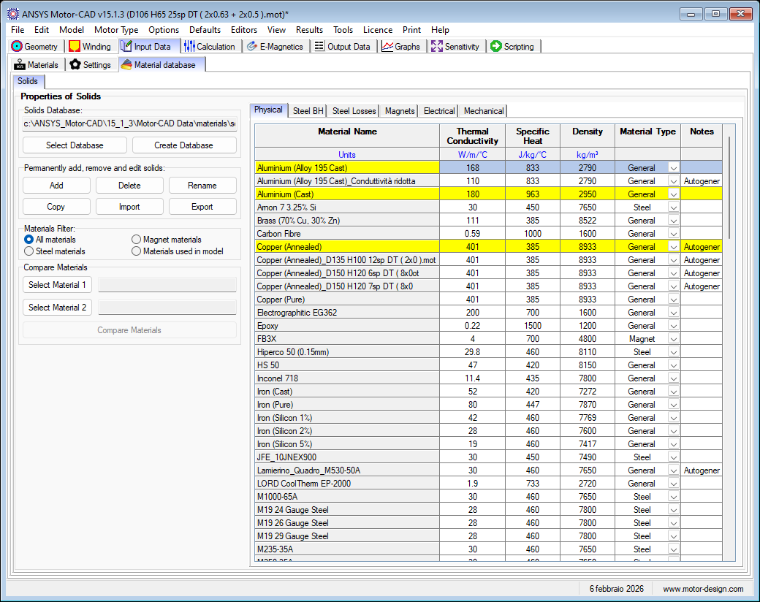

Aluminium (Alloy 195 Cast)

Electrical

Screenshot
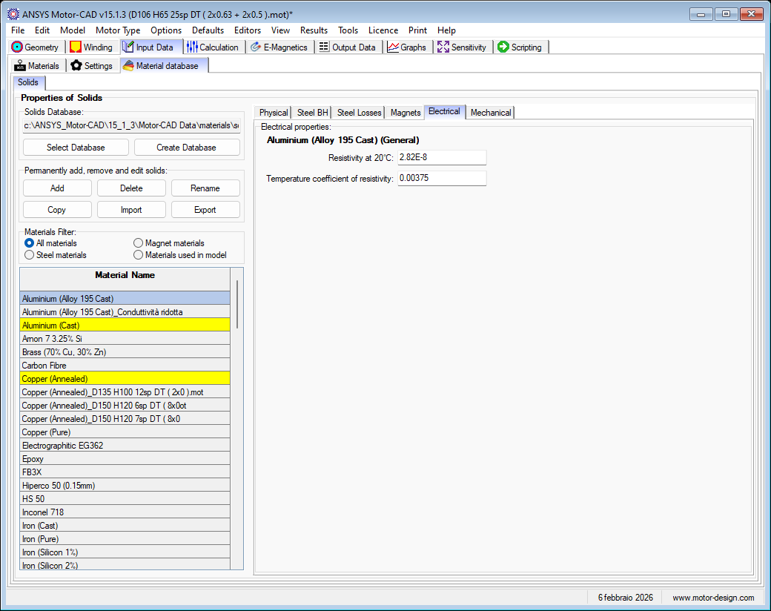

Aluminium (Cast)

Electrical

Screenshot
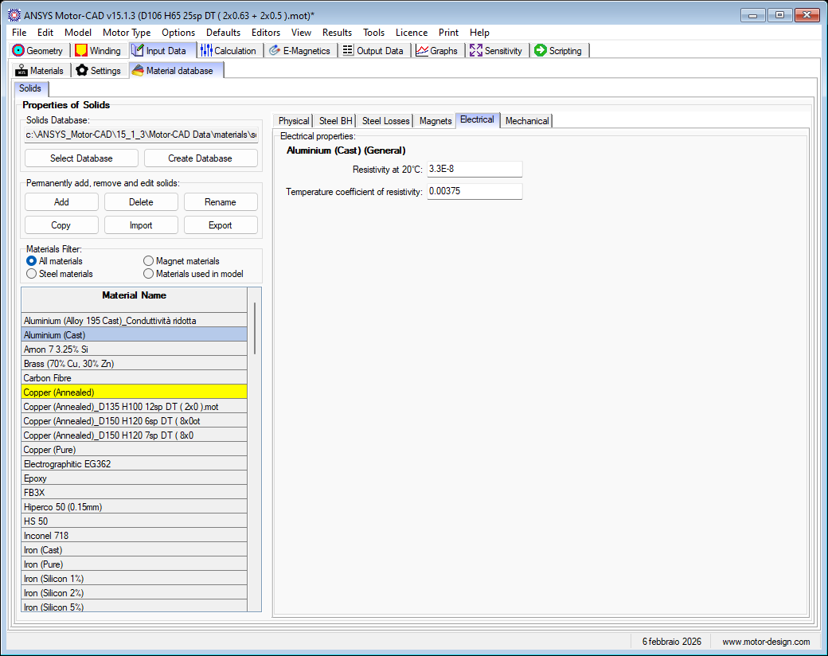

Copper (Annealed)

Electrical

Screenshot
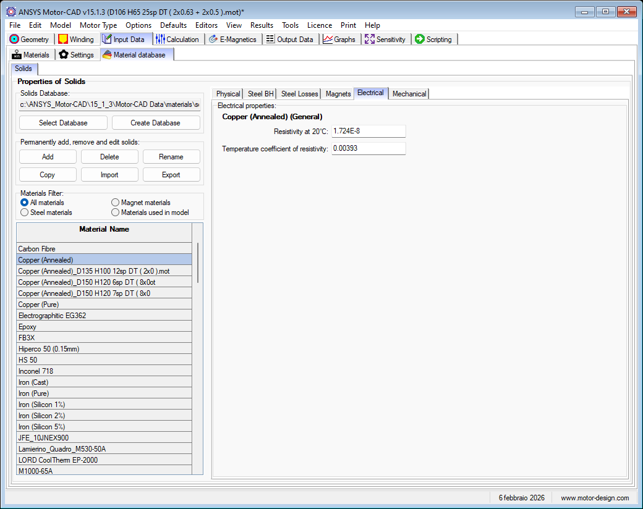

M800-50A

Steel BH

B vs H

Graph: Flux Density vs Magnetic Field for M800-50A
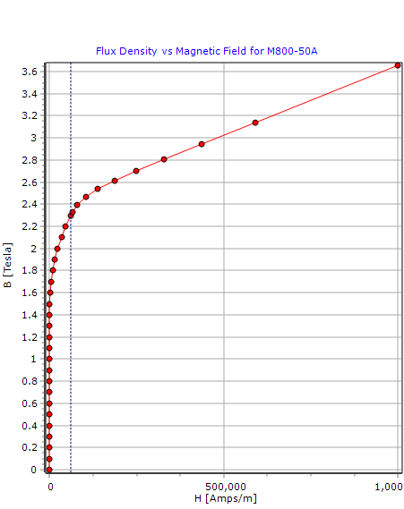

Table: BH List
B | H
Tesla | Amps/m
0 | 0
0.1 | 49.4217
0.2 | 91.7567
0.3 | 118.7541
0.4 | 135.6164
0.5 | 146.0186
0.6 | 156.966
0.7 | 168.252
0.8 | 180.8315
0.9 | 195.0656
1 | 213.5262
1.1 | 237.706
1.2 | 277.5238
1.3 | 345.8256
1.4 | 514.7918
1.5 | 1046.9084
1.6 | 2414.3523
1.7 | 4944.6712
1.8 | 9210.2309
1.9 | 15812.345
2 | 24353.364
2.1 | 34708.362
2.2 | 46723.556
2.3 | 60861.778
2.3304181 | 65569.267
2.3979793 | 79836.223
2.4708791 | 104119.23
2.5417189 | 139265.6
2.6162961 | 186682.44
2.7024281 | 248689.42
2.8083086 | 329321.16
2.9456195 | 436517.07
3.1408564 | 590639.14
3.6564981 | 1000000

Screenshot
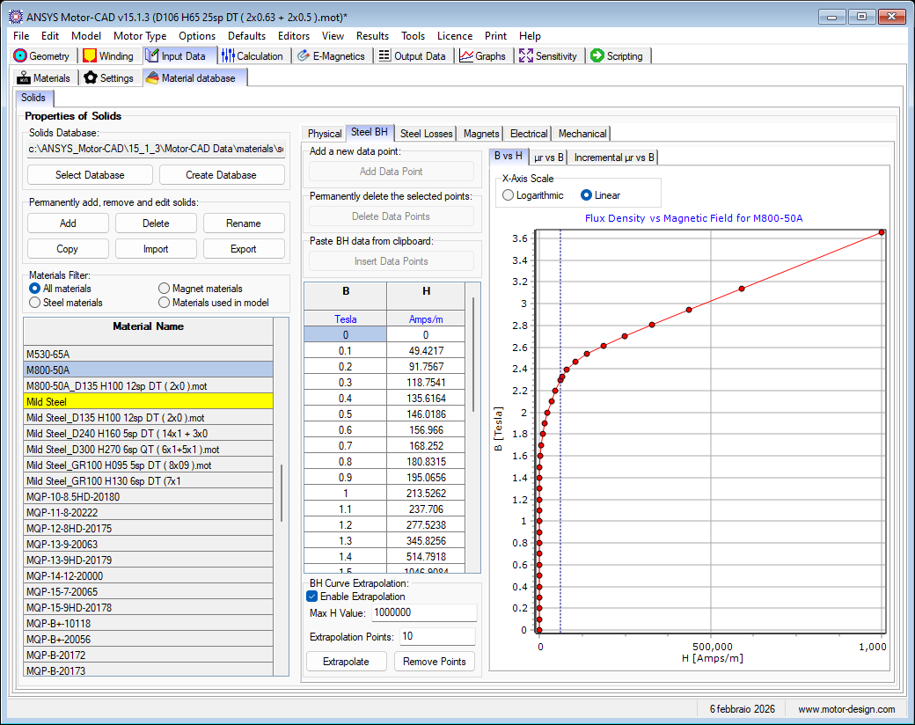

μr vs B

Graph: Relative Permeability vs Flux Density for M800-50A
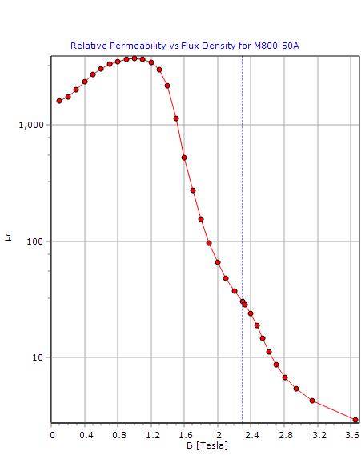

Table: BH List
B | H
Tesla | Amps/m
0 | 0
0.1 | 49.4217
0.2 | 91.7567
0.3 | 118.7541
0.4 | 135.6164
0.5 | 146.0186
0.6 | 156.966
0.7 | 168.252
0.8 | 180.8315
0.9 | 195.0656
1 | 213.5262
1.1 | 237.706
1.2 | 277.5238
1.3 | 345.8256
1.4 | 514.7918
1.5 | 1046.9084
1.6 | 2414.3523
1.7 | 4944.6712
1.8 | 9210.2309
1.9 | 15812.345
2 | 24353.364
2.1 | 34708.362
2.2 | 46723.556
2.3 | 60861.778
2.3304181 | 65569.267
2.3979793 | 79836.223
2.4708791 | 104119.23
2.5417189 | 139265.6
2.6162961 | 186682.44
2.7024281 | 248689.42
2.8083086 | 329321.16
2.9456195 | 436517.07
3.1408564 | 590639.14
3.6564981 | 1000000

Screenshot
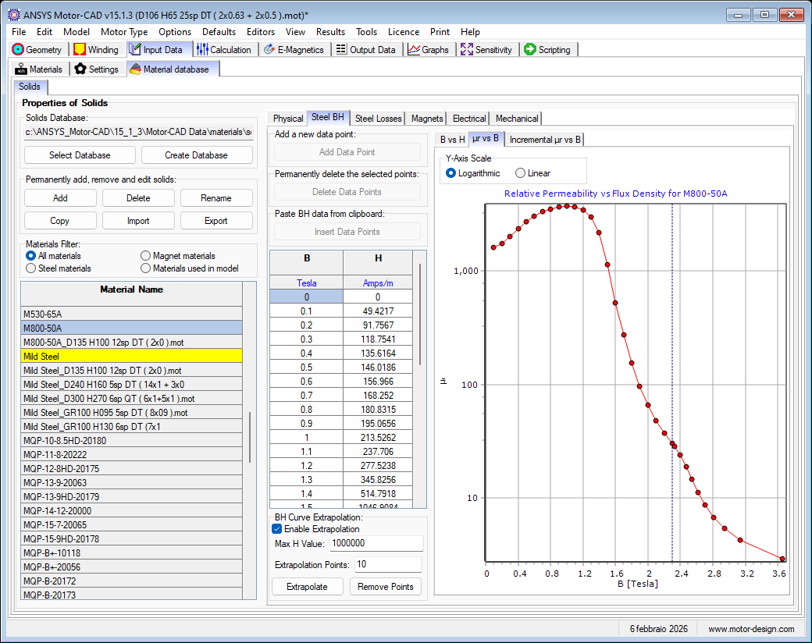

Incremental μr vs B

Graph: Incremental Relative Permeability vs Flux Density for M800-50A
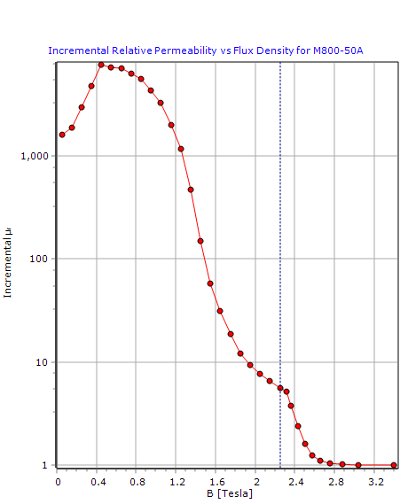

Table: BH List
B | H
Tesla | Amps/m
0 | 0
0.1 | 49.4217
0.2 | 91.7567
0.3 | 118.7541
0.4 | 135.6164
0.5 | 146.0186
0.6 | 156.966
0.7 | 168.252
0.8 | 180.8315
0.9 | 195.0656
1 | 213.5262
1.1 | 237.706
1.2 | 277.5238
1.3 | 345.8256
1.4 | 514.7918
1.5 | 1046.9084
1.6 | 2414.3523
1.7 | 4944.6712
1.8 | 9210.2309
1.9 | 15812.345
2 | 24353.364
2.1 | 34708.362
2.2 | 46723.556
2.3 | 60861.778
2.3304181 | 65569.267
2.3979793 | 79836.223
2.4708791 | 104119.23
2.5417189 | 139265.6
2.6162961 | 186682.44
2.7024281 | 248689.42
2.8083086 | 329321.16
2.9456195 | 436517.07
3.1408564 | 590639.14
3.6564981 | 1000000

Screenshot
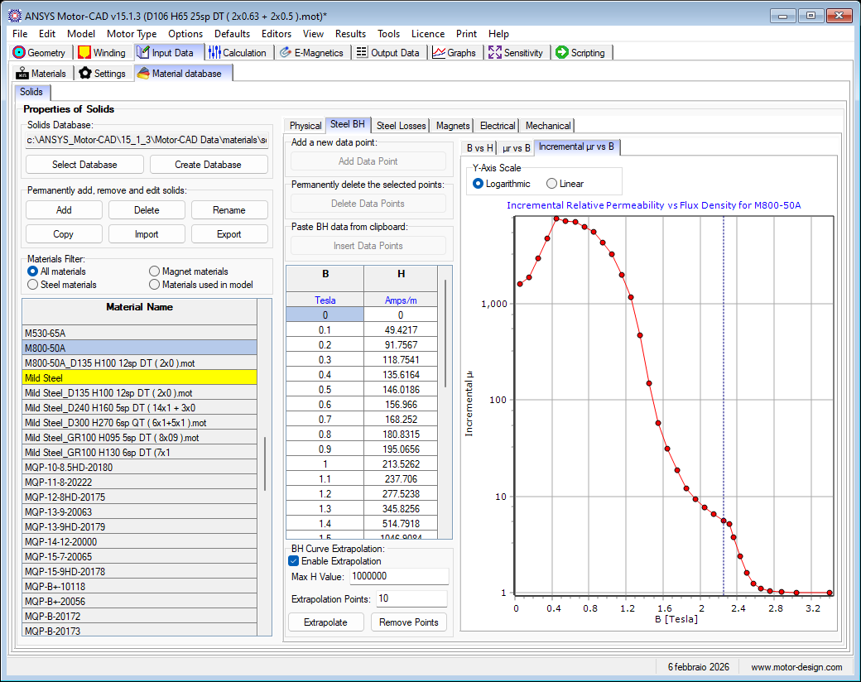

Steel Losses

Steel Properties

Screenshot
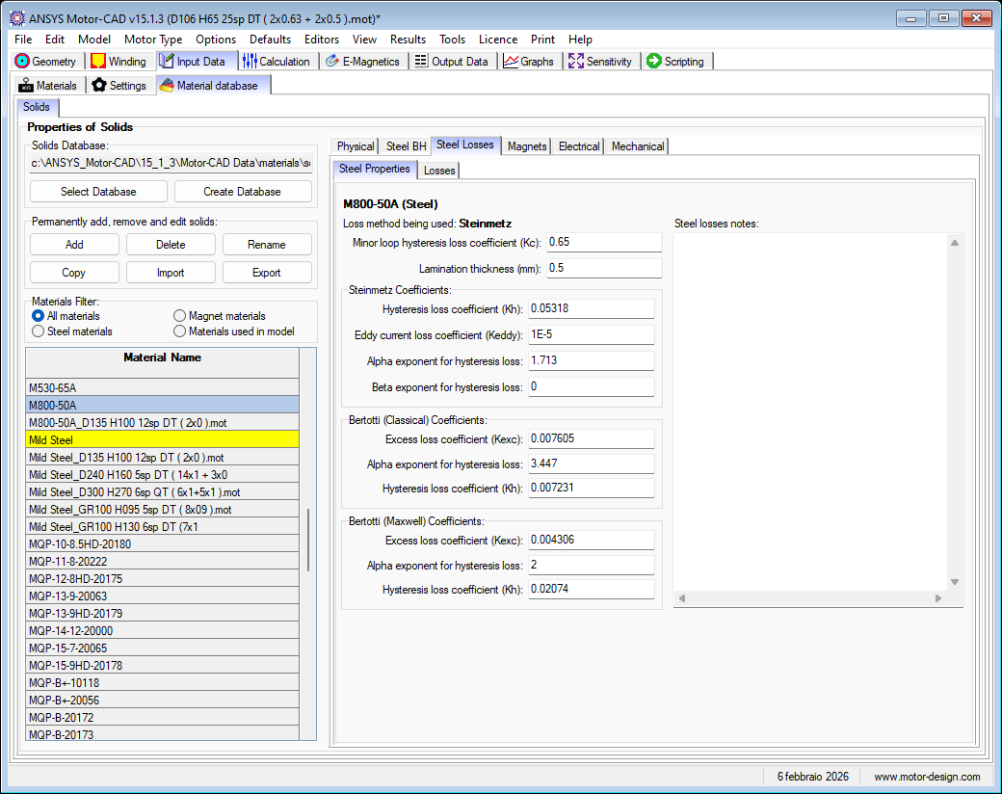

Losses

Graph: Loss Density vs Flux Density for M800-50A
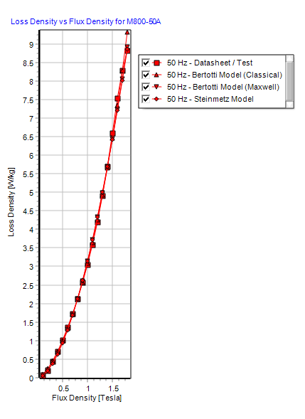

Table: Iron Loss Data
Frequency | Loss Density | Flux Density
Hz | W/kg | Tesla
50 | 0.05 | 0.1
50 | 0.18 | 0.2
50 | 0.43 | 0.3
50 | 0.7 | 0.4
50 | 1.01 | 0.5
50 | 1.35 | 0.6
50 | 1.72 | 0.7
50 | 2.13 | 0.8
50 | 2.56 | 0.9
50 | 3.05 | 1
50 | 3.59 | 1.1
50 | 4.2 | 1.2
50 | 4.91 | 1.3
50 | 5.7 | 1.4
50 | 6.6 | 1.5
50 | 7.54 | 1.6
50 | 8.3 | 1.7

Electrical

Screenshot
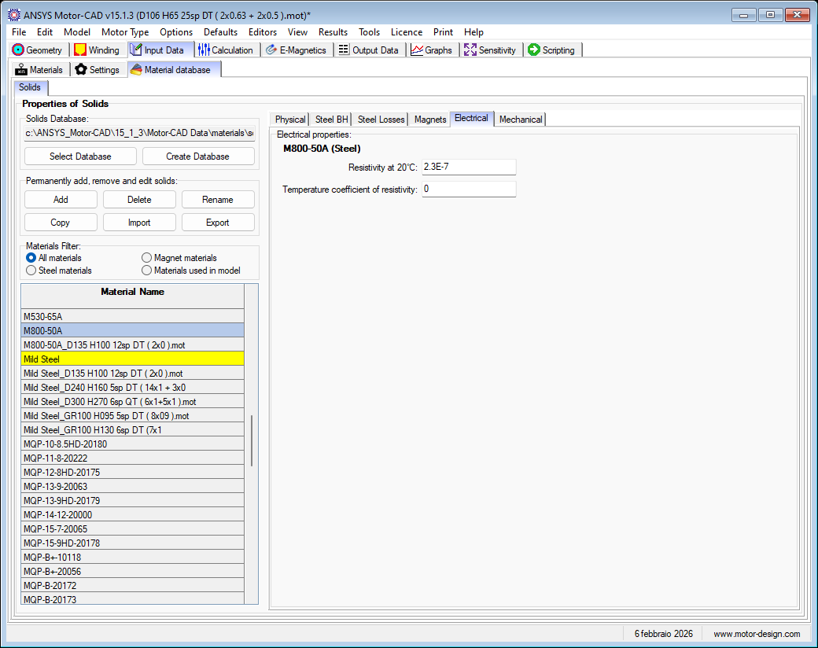

Mild Steel

Steel BH

B vs H

Graph: Flux Density vs Magnetic Field for Mild Steel
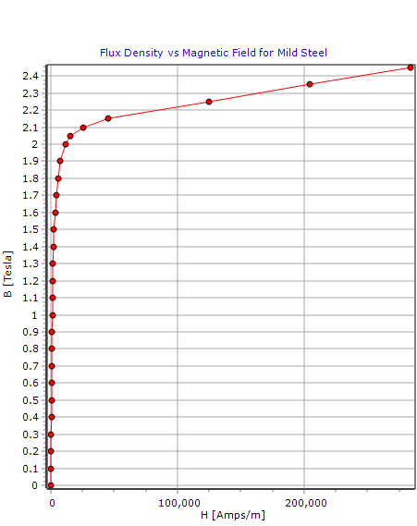

Table: BH List
B | H
Tesla | Amps/m
0 | 0
0.1 | 117.9112
0.2 | 235.742
0.3 | 353.705
0.4 | 471.4946
0.5 | 589.464
0.6 | 707.3321
0.7 | 825
0.8 | 943.2034
0.9 | 1061
1 | 1179.5384
1.1 | 1299
1.2 | 1425
1.3 | 1565
1.4 | 1832.0513
1.5 | 2480.35
1.6 | 3326.2307
1.7 | 4500
1.8 | 5860
1.9 | 7600
2 | 11500
2.05 | 15479
2.1 | 25426
2.15 | 45320
2.25 | 124900
2.35 | 204470
2.45 | 284050

μr vs B

Graph: Relative Permeability vs Flux Density for Mild Steel
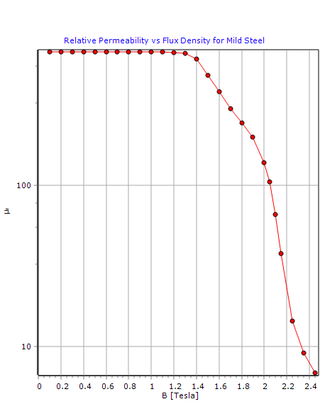

Table: BH List
B | H
Tesla | Amps/m
0 | 0
0.1 | 117.9112
0.2 | 235.742
0.3 | 353.705
0.4 | 471.4946
0.5 | 589.464
0.6 | 707.3321
0.7 | 825
0.8 | 943.2034
0.9 | 1061
1 | 1179.5384
1.1 | 1299
1.2 | 1425
1.3 | 1565
1.4 | 1832.0513
1.5 | 2480.35
1.6 | 3326.2307
1.7 | 4500
1.8 | 5860
1.9 | 7600
2 | 11500
2.05 | 15479
2.1 | 25426
2.15 | 45320
2.25 | 124900
2.35 | 204470
2.45 | 284050

Incremental μr vs B

Graph: Incremental Relative Permeability vs Flux Density for Mild Steel
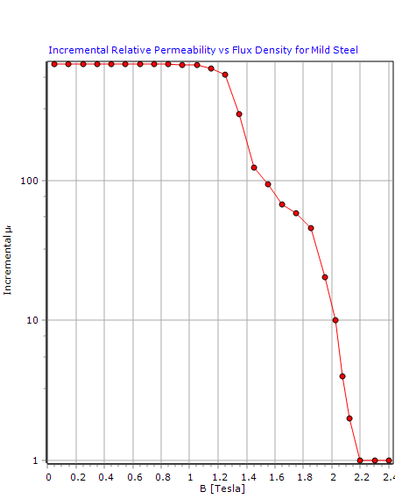

Table: BH List
B | H
Tesla | Amps/m
0 | 0
0.1 | 117.9112
0.2 | 235.742
0.3 | 353.705
0.4 | 471.4946
0.5 | 589.464
0.6 | 707.3321
0.7 | 825
0.8 | 943.2034
0.9 | 1061
1 | 1179.5384
1.1 | 1299
1.2 | 1425
1.3 | 1565
1.4 | 1832.0513
1.5 | 2480.35
1.6 | 3326.2307
1.7 | 4500
1.8 | 5860
1.9 | 7600
2 | 11500
2.05 | 15479
2.1 | 25426
2.15 | 45320
2.25 | 124900
2.35 | 204470
2.45 | 284050

Steel Losses

Steel Properties

Screenshot
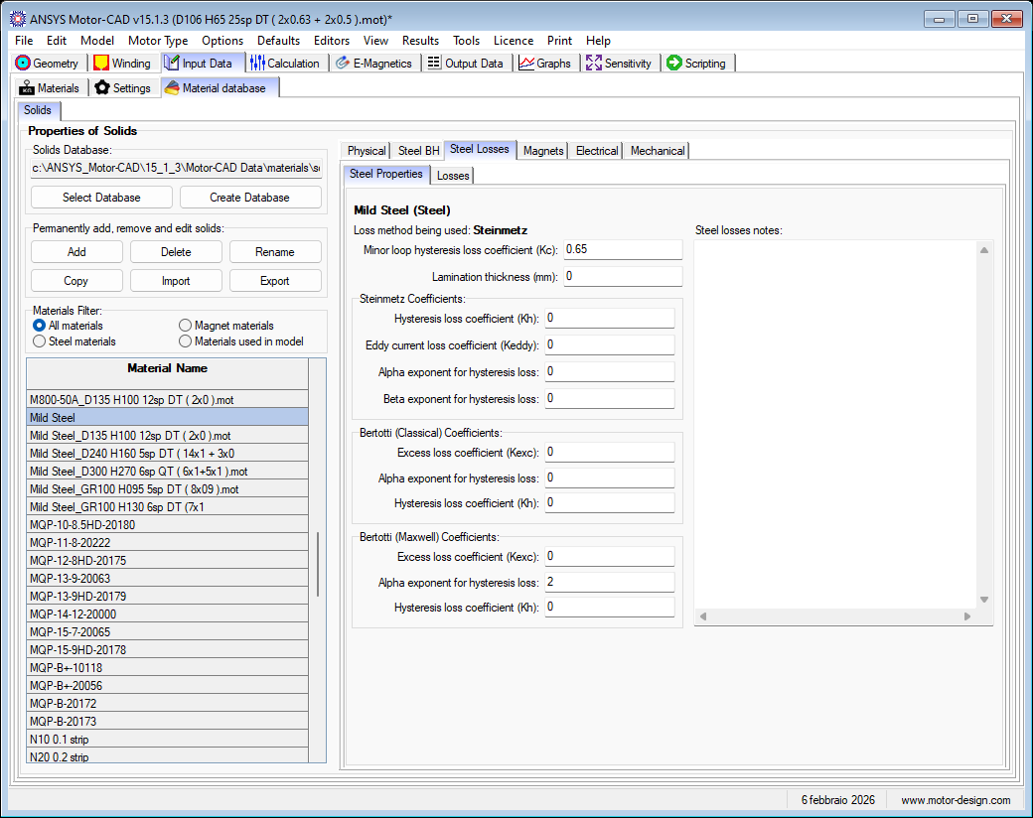

Losses

Table: Iron Loss Data
Frequency | Loss Density | Flux Density
Hz | W/kg | Tesla

Electrical

Screenshot
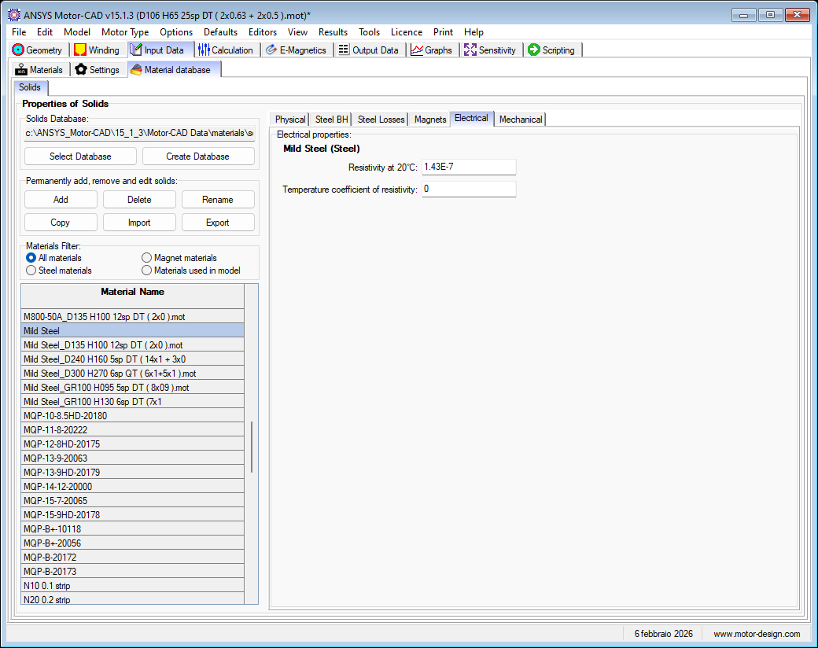

50 | 8.83 | 1.8  Screenshot  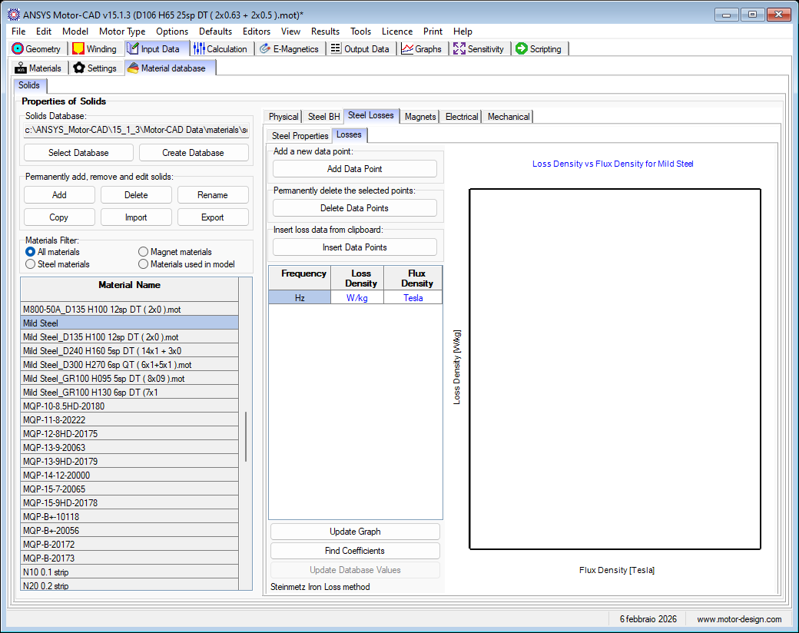  Scre  Screenshot  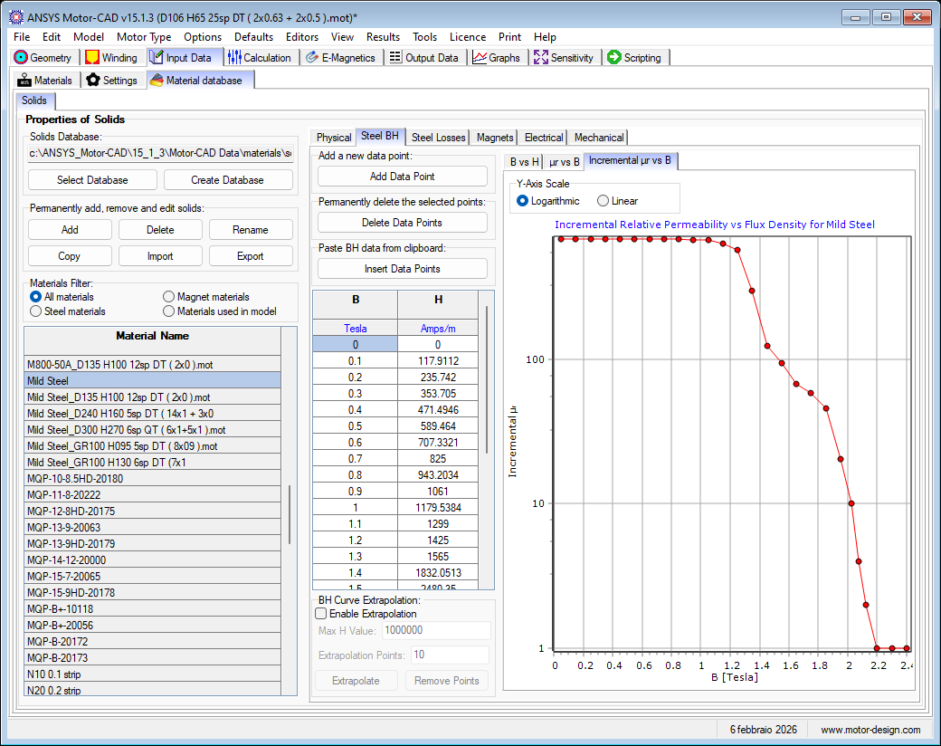  enshot  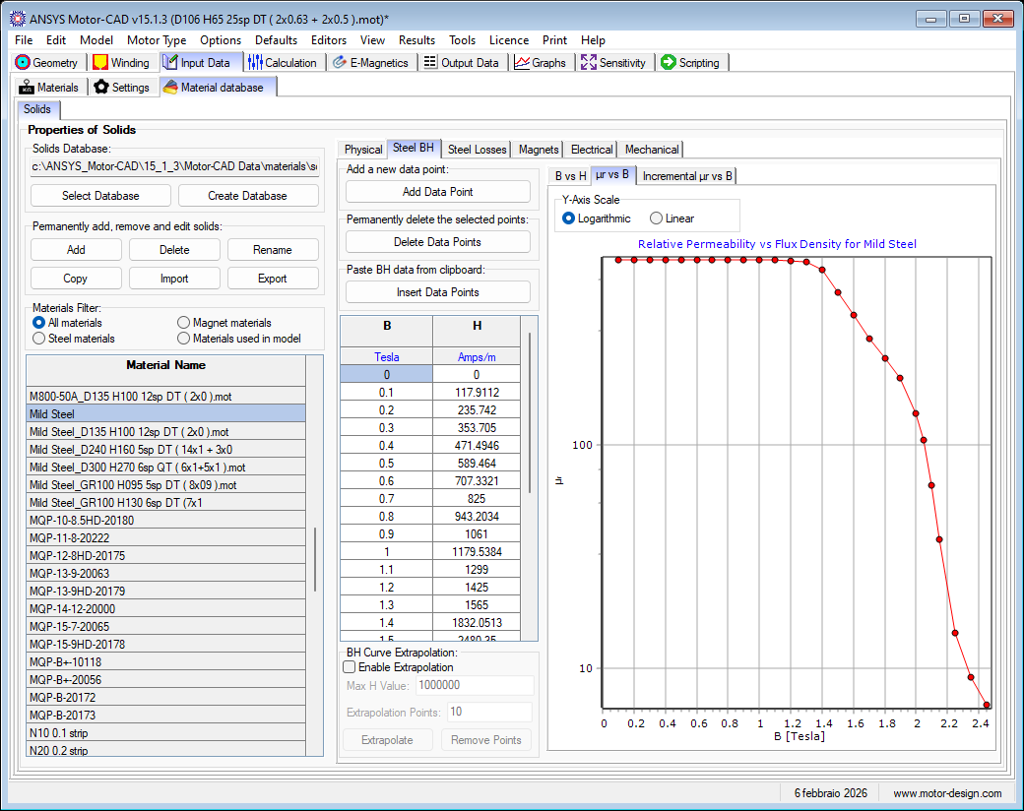  Scre  Screenshot  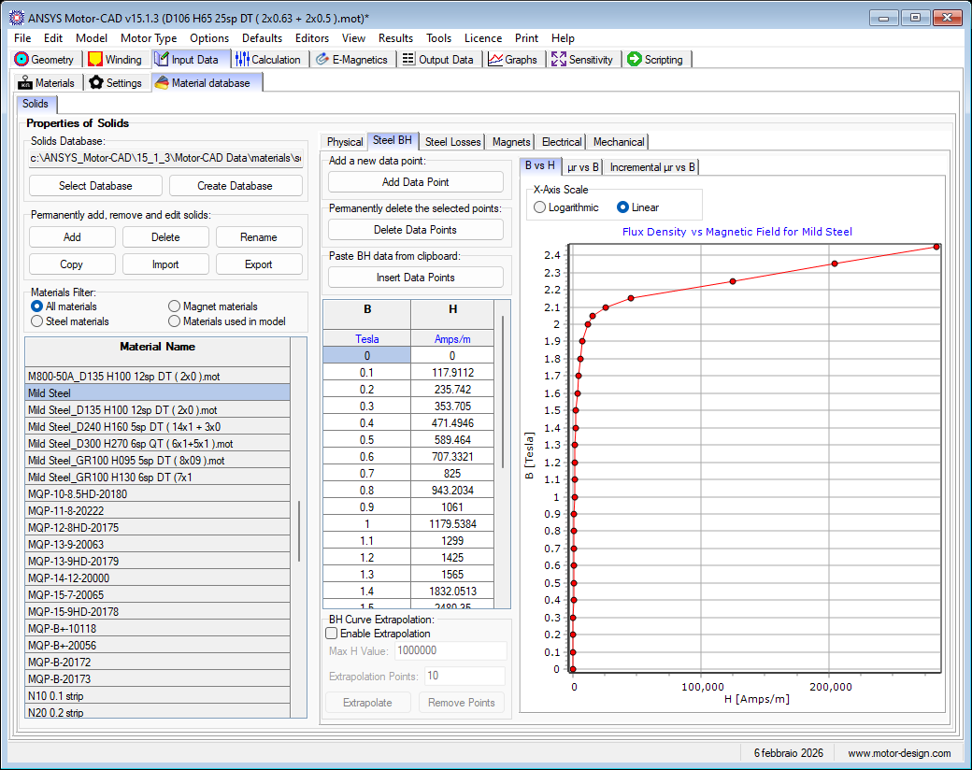  enshot  